

PNEUMONIA DETECTION USING DEEP LEARNING
An explainable three-class chest X-ray classifier with a web application
A project report submitted in partial fulfilment of the requirements for the award of the degree of
BACHELOR OF TECHNOLOGY
in
COMPUTER SCIENCE AND ENGINEERING
Submitted by
CHOUDAM AKSHITHA | 23K91A0556
BOGGULA SATVIK KUMAR | 23K91A0541
ARUTLA ABHI THEJ REDDY | 23K91A0515
DUGGARAJU LIKHITHA | 23K91A0565

Batch A12 (CSE-A)
Under the esteemed guidance of
V. MEENAKSHI
[DESIGNATION]
DEPARTMENT OF COMPUTER SCIENCE AND ENGINEERING
TKR COLLEGE OF ENGINEERING AND TECHNOLOGY (AUTONOMOUS)
Medbowli, Meerpet, Balapur, Hyderabad, Telangana - 500 097
Academic year 2026-2027

CERTIFICATE
This is to certify that the project report entitled "Pneumonia Detection Using Deep Learning" is a bonafide record of the work carried out by CHOUDAM AKSHITHA (23K91A0556), BOGGULA SATVIK KUMAR (23K91A0541), ARUTLA ABHI THEJ REDDY (23K91A0515), DUGGARAJU LIKHITHA (23K91A0565), in partial fulfilment of the requirements for the award of the degree of Bachelor of Technology in Computer Science and Engineering, during the academic year 2026-2027, under my supervision.

Project Guide | Head of the Department | Principal
V. MEENAKSHI | [HOD NAME] | [PRINCIPAL NAME]
[DESIGNATION] | Department of Computer Science and Engineering | TKR College of Engineering and Technology (Autonomous)

External Examiner: [NAME AND SIGNATURE]
Place: Hyderabad
Date: [DATE]

DECLARATION
We hereby declare that the project report entitled "Pneumonia Detection Using Deep Learning", submitted to the Department of Computer Science and Engineering, TKR College of Engineering and Technology (Autonomous), in partial fulfilment of the requirements for the award of the degree of Bachelor of Technology in Computer Science and Engineering, is a record of original work carried out by us under the guidance of V. MEENAKSHI, [DESIGNATION]. The results embodied in this report have not been submitted to any other university or institution for the award of any degree or diploma.

CHOUDAM AKSHITHA 23K91A0556
BOGGULA SATVIK KUMAR 23K91A0541
ARUTLA ABHI THEJ REDDY 23K91A0515
DUGGARAJU LIKHITHA 23K91A0565

Place: Hyderabad
Date: [DATE]

ACKNOWLEDGEMENT
We express our sincere gratitude to our project guide, V. MEENAKSHI, [DESIGNATION], for valuable guidance, encouragement and constructive suggestions throughout this project.
We thank [HOD NAME], Head of the Department of Computer Science and Engineering, for providing the facilities and support needed to complete this work, and [PRINCIPAL NAME], Principal, TKR College of Engineering and Technology (Autonomous), for the encouragement given to us.
We thank the project coordinators and all faculty and staff members of the department for their help, and our families and friends for their constant support.
We also acknowledge the authors of the base paper, the creators of the public chest X-ray dataset released under CC BY 4.0, and the developers of the open-source software used in this project (TensorFlow, OpenCV, FastAPI, Flask, React and Vite).

CHOUDAM AKSHITHA
BOGGULA SATVIK KUMAR
ARUTLA ABHI THEJ REDDY
DUGGARAJU LIKHITHA

ABSTRACT
Pneumonia is a leading infectious cause of death, and chest X-ray readers are scarce where the disease is most dangerous. Manual reading is slow and varies between readers, and most published classifiers return a label with no visual justification. This project builds an end-to-end, explainable pneumonia detection system. An uploaded chest X-ray is validated, enhanced with contrast-limited adaptive histogram equalisation, classified by a compact convolutional neural network into Normal, Bacterial Pneumonia or Viral Pneumonia with a probability for each class, and explained with a Grad-CAM heat map; every scan is stored in a history that a dashboard summarises.
The network (590,019 parameters, trained on a desktop CPU) was trained on the public Kermany paediatric chest X-ray data with a patient-level validation split. On the official 624-image test split it reaches 79.5% three-class accuracy and a macro F1 of 0.780; viewed as pneumonia against normal it has 98.7% sensitivity and 62.0% specificity. Normal radiographs are the weak point: many are called pneumonia, mostly viral. Because many pneumonia ids in the official test folder also occur in the training folders, results on the patient-disjoint part of the test split and on a fully patient-level re-partition are reported as well, and every figure is stated together with its protocol. Datasets and protocols differ from those of the base paper, so the comparison is given as context, not as a ranking.
The model is served by a FastAPI layer over the original Flask project's code, behind a React interface with a demo login, history search, CSV export and a printable report. 73 automated tests, a live smoke test and browser checks at 360, 768 and 1440 pixels pass. U-Net lung segmentation, calibrated uncertainty and external validation were not implemented and are listed as limitations and future work. The system is a research prototype and not a medical device.
Keywords: pneumonia detection, chest X-ray, deep learning, convolutional neural network, CLAHE, Grad-CAM, explainable AI, medical image analysis, FastAPI, React.

TABLE OF CONTENTS
CERTIFICATE i
DECLARATION ii
ACKNOWLEDGEMENT iii
ABSTRACT iv
TABLE OF CONTENTS v
LIST OF FIGURES ix
LIST OF TABLES xi
LIST OF ABBREVIATIONS xii
CHAPTER 1: INTRODUCTION 1
1.1 Domain overview 1
1.2 Background and motivation 1
1.3 Problem statement 2
1.4 Need for the system 2
1.5 Objectives 2
1.6 Scope 2
1.7 Contributions 3
1.8 Limitations and assumptions 4
1.9 Organisation of the report 5
CHAPTER 2: LITERATURE SURVEY 6
2.1 Overview 6
2.2 Base paper analysis 6
2.3 Related work by theme 8
2.4 Datasets and algorithms in the literature 10
2.5 Strengths and limitations of the surveyed work 10
2.6 Research gap 10
CHAPTER 3: FEASIBILITY STUDY 12
3.1 Technical feasibility 12
3.2 Economic feasibility 12
3.3 Operational feasibility 12
3.4 Schedule feasibility 13
3.5 Legal and ethical considerations 13
3.6 Advantages and constraints 13
CHAPTER 4: SYSTEM REQUIREMENTS AND ANALYSIS 14
4.1 Existing system and its limitations 14
4.2 Proposed system and its advantages 14
4.3 Functional requirements 14
4.4 Non-functional requirements 15
4.5 Hardware requirements 16
4.6 Software requirements 16
4.7 User roles 16
4.8 Constraints 16
CHAPTER 5: SYSTEM DESIGN 17
5.1 Architecture 17
5.2 High-level workflow 18
5.3 Data flow diagrams 19
5.4 UML diagrams 22
5.5 Database design 26
5.6 Module design 27
5.7 API design 27
5.8 User interface design 28
CHAPTER 6: METHODOLOGY AND SOFTWARE IMPLEMENTATION 30
6.1 Overall methodology 30
6.2 Dataset 30
6.3 Preprocessing 31
6.4 Algorithm choice and justification 32
6.5 Mathematical formulation 33
6.6 Model architecture and training 34
6.7 Application architecture 35
6.8 API design 36
6.9 Security and error handling 36
6.10 Installation and execution 37
CHAPTER 7: SYSTEM TESTING 38
7.1 Testing strategy 38
7.2 Unit tests 38
7.3 Integration tests 38
7.4 Functional tests 39
7.5 Security tests 39
7.6 Validation and edge cases 39
7.7 Performance testing 40
7.8 User acceptance 40
7.9 Limits of the testing done 41
CHAPTER 8: RESULTS AND OUTPUT SCREENS 42
8.1 Output screens 42
8.2 Experimental setup and protocol 48
8.3 Model performance on the official test split 49
8.4 Overlap between the training and test folders 51
8.5 Ablation and comparison with MobileNetV3Small 52
8.6 Threshold analysis 53
8.7 Comparison with the base paper 55
8.8 Sample inputs and outputs 56
8.9 Success and failure analysis 56
8.10 Limitations of the results 57
8.11 Objectives against outcomes 57
CHAPTER 9: CONCLUSION 59
9.1 Summary 59
9.2 Objectives achieved 59
9.3 Key findings 59
9.4 Practical applications 60
9.5 Known limitations 60
CHAPTER 10: FUTURE SCOPE 61
10.1 Improvements to the model 61
10.2 Additional features 61
10.3 Scalability and deployment 61
10.4 Further research 61
REFERENCES 63
APPENDIX A: IMPORTANT CODE 65
A.1 Preprocessing (`model/preprocess.py`) 65
A.2 Network definition (`model/model_builder.py`) 65
A.3 Grad-CAM (`model/gradcam.py`) 66
A.4 Database layer (`database/db.py`) 67
A.5 Session tokens and login (`backend/main.py`) 68
A.6 Prediction route (`backend/main.py`) 68
A.7 Training and evaluation (`scripts/train_experiment.py`) 69
APPENDIX B: INSTALLATION AND USER GUIDE 71
B.1 Requirements 71
B.2 One-click start 71
B.3 Manual start 71
B.4 Using the application 71
B.5 Training a model 72
B.6 Running the tests 72
B.7 Troubleshooting 72
APPENDIX C: ADDITIONAL SCREENS 73

LIST OF FIGURES
Figure 1: System architecture of the pneumonia detection system 17
Figure 2: High-level workflow of one scan, from sign-in to review 18
Figure 3: Data flow diagram, level 0 (context diagram) 19
Figure 4: Data flow diagram, level 1 20
Figure 5: Data flow diagram, level 2: process 3.0 expanded 21
Figure 6: UML class diagram (modules drawn as classes) 22
Figure 7: Sequence diagram: analysing one X-ray 23
Figure 8: Use-case diagram 24
Figure 9: Flowchart of the core algorithm (POST /api/predict) 25
Figure 10: Entity-relationship diagram of the stored data 26
Figure 11: The result screen: side-by-side original and Grad-CAM overlay, class badge and probabilities 29
Figure 12: Overall workflow used at inference time (the same preprocessing is used for training) 30
Figure 13: Images per class in the training, validation and test sets used by the main experiment 31
Figure 14: Preprocessing steps applied to a normal and a pneumonia radiograph (public-domain sample images) 32
Figure 15: Landing page (light theme): hero, how the pipeline works, the three classes and the clinical disclaimer 42
Figure 16: Detect screen with a preview of the selected radiograph and the Analyse button 43
Figure 17: Result screen: original X-ray beside the Grad-CAM overlay, class badge, confidence and the three probability bars 44
Figure 18: Result screen, blended view: a slider sets how strongly the heat map is laid over the X-ray 45
Figure 19: Dashboard: totals, class distribution, scans per day and the most recent scans 46
Figure 20: History: searchable, filterable, sortable table with thumbnails and CSV export 47
Figure 21: About screen: abstract, the five-step pipeline, technology and disclaimer 48
Figure 22: Training and validation accuracy and loss of the main experiment (dotted line: best epoch) 49
Figure 23: Confusion matrix on the official test split (rows: true class, columns: predicted class) 50
Figure 24: Per-class precision, recall and F1 on the official test split 50
Figure 25: Confusion matrix of the patient-level re-partition 52
Figure 26: Comparison of the experiments on the official test images 53
Figure 27: Accuracy on the scans kept and coverage as the minimum confidence rises 54
Figure 28: Sensitivity, specificity and accuracy against the pneumonia decision threshold 54
Figure 29: Grad-CAM overlays for the highest-confidence correct test image of each class and the most confident misclassification 56
Figure 30: Landing page, light theme 73
Figure 31: Landing page, dark theme 74
Figure 32: Sign-in screen with the demo credentials box 75
Figure 33: Detect screen before a file is chosen 75
Figure 34: Detect screen with a preview and the analyse button 76
Figure 35: Result screen, blended heat-map view 76
Figure 36: Result screen, dark theme 77
Figure 37: Dashboard, dark theme 78
Figure 38: About screen 79
Figure 39: Result screen in Demo Mode (untrained network, before the model was trained): the amber banner and the near-equal probabilities are the warning that the output is meaningless 80
Figure 40: Detect screen in Demo Mode 81

LIST OF TABLES
Table 1: Abbreviations used in this report xii
Table 2: Organisation of this report 5
Table 3: Summary of the works compared 9
Table 4: Datasets used in the surveyed work 10
Table 5: Cost view 12
Table 6: Functional requirements 14
Table 7: Non-functional requirements and how each is verified 15
Table 8: Hardware 16
Table 9: Software 16
Table 10: Roles 16
Table 11: Table predictions 26
Table 12: Modules and responsibilities 27
Table 13: REST endpoints 27
Table 14: Screens 28
Table 15: Official folders and the three project classes 30
Table 16: Choices and reasons 32
Table 17: Layers of the deployed network 34
Table 18: Training configuration of the main experiment 35
Table 19: Controls 36
Table 20: Test layers 38
Table 21: Unit tests 38
Table 22: Security checks 39
Table 23: Requirement traceability 40
Table 24: Protocol of the main experiment 48
Table 25: Per-class results on the official test split (n = 624) 49
Table 26: Binary view of the same predictions 50
Table 27: Full official test split against the id-disjoint subset 51
Table 28: Experiments compared 52
Table 29: Accuracy against minimum confidence 53
Table 30: Pneumonia decision-threshold sweep 54
Table 31: Base paper and this project 55
Table 32: Sample radiographs through the deployed API 56
Table 33: Objectives of Section 1.5 and their outcome 57
Table 34: Walk-through 71

LIST OF ABBREVIATIONS
Table 1: Abbreviations used in this report
Abbreviation | Expansion
AI | Artificial Intelligence
API | Application Programming Interface
AUC | Area Under the ROC Curve
BN | Batch Normalisation
CAM | Class Activation Mapping
CLAHE | Contrast Limited Adaptive Histogram Equalisation
CNN | Convolutional Neural Network
CORS | Cross-Origin Resource Sharing
CPU | Central Processing Unit
CSV | Comma-Separated Values
CXR | Chest X-Ray
DFD | Data Flow Diagram
ECE | Expected Calibration Error
ER | Entity-Relationship
FN / FP | False Negative / False Positive
GAP | Global Average Pooling
GPU | Graphics Processing Unit
Grad-CAM | Gradient-weighted Class Activation Mapping
HMAC | Hash-based Message Authentication Code
HTTP | Hypertext Transfer Protocol
JPEG / PNG | Image file formats
JSON | JavaScript Object Notation
ReLU | Rectified Linear Unit
REST | Representational State Transfer
ROC | Receiver Operating Characteristic
SPA | Single-Page Application
SQL | Structured Query Language
TN / TP | True Negative / True Positive
UI | User Interface
UML | Unified Modeling Language
WHO | World Health Organization

CHAPTER 1: INTRODUCTION

1.1 Domain overview
Pneumonia is an infection that inflames the air sacs of one or both lungs. It remains one of the leading infectious causes of death, particularly among children under five and elderly people [1], [2]. The chest X-ray is the most widely used first-line imaging test for the disease because it is fast, inexpensive and available in almost every clinic. Interpreting it, however, requires an experienced reader: opacities can be subtle, their appearance overlaps with other respiratory illnesses, and the same film can be read differently by two clinicians.
Deep learning, and convolutional neural networks (CNNs) in particular, has become the dominant technique for automatic analysis of medical images [28]. On chest radiographs, CNNs have been shown to approach radiologist-level performance for pneumonia detection [7] and a large body of work now compares architectures, preprocessing choices and explanation methods on public datasets [1], [5], [6]. The domain of this project is therefore Artificial Intelligence and Machine Learning applied to medical image analysis and clinical decision support.

1.2 Background and motivation
Radiologists are scarce in exactly the settings where pneumonia is most dangerous: rural clinics, paediatric wards in low-resource hospitals and emergency departments at night. A tool that gives a first opinion within seconds, and shows why it reached that opinion, could help a non-specialist decide whether a case needs urgent escalation. Two properties make such a tool credible. First, it must separate the clinically important classes: normal film, bacterial pneumonia (usually treated with antibiotics) and viral pneumonia (usually not). Second, it must be transparent: a bare label from a black-box network is not acceptable in a clinical workflow, whereas a heat map that highlights the lung regions that drove the decision can be checked against the image [9].
The base paper for this project [1] studies lightweight MobileNet networks, semi-supervised learning and uncertainty estimation for chest X-ray classification and uses Grad-CAM to confirm that predictions rely on clinically relevant regions. It targets research benchmarks. The motivation of this project is complementary: to build the whole path from an uploaded image to an explained, stored and reviewable prediction, and to measure honestly how well a compact CNN performs inside that path.

1.3 Problem statement
• Radiologist shortage delays diagnosis in exactly the settings where pneumonia is most dangerous.
• Manual X-ray interpretation is subject to fatigue and inter-observer variation.
• Most published classifiers report accuracy alone and give no visual justification.
• A black-box prediction cannot be accepted into a clinical workflow without explanation.
The problem addressed here is: given a single chest X-ray, classify it as Normal, Bacterial Pneumonia or Viral Pneumonia, report the probability of each class, show which image regions supported the decision, and keep a reviewable record, all through a web interface a non-expert can use.

1.4 Need for the system
The need is for an accurate pneumonia classifier that explains every prediction visually. Existing research code seldom provides an interface, a history of past scans or a way to inspect a prediction later; existing clinical software is closed and expensive. An open, inspectable implementation lets students, researchers and developers study the full pipeline, reproduce the numbers and extend it.

1.5 Objectives
The project was proposed with the following objectives. Chapter 8 reports, for each, whether it was achieved.
1. Acquire and preprocess a chest X-ray dataset with consistent resizing, normalisation and augmentation.
2. Apply U-Net based lung segmentation to isolate the region of interest before classification.
3. Train a CNN classifier to distinguish pneumonia-positive from normal chest X-rays.
4. Evaluate using accuracy, sensitivity, specificity, F1-score and a confusion matrix.
5. Generate heatmap visualisations so each prediction can be verified against the image.
6. Deploy the model behind an interface that returns the prediction with its confidence and heatmap.

1.6 Scope
In scope.
• Three-way classification of a single frontal chest X-ray into Normal, Bacterial Pneumonia or Viral Pneumonia, with per-class probabilities.
• The preprocessing chain actually used in the code: grayscale decoding, resizing to 224 x 224, CLAHE contrast enhancement, light Gaussian smoothing and scaling to [0, 1].
• A convolutional network written for the project (four convolution blocks, global average pooling and a dense head), plus a transfer-learning builder for DenseNet, ResNet and EfficientNet backbones.
• A Grad-CAM heatmap overlay for the predicted class on every scan.
• A web application with a React front end, a FastAPI service and the original Flask interface, a signed-cookie demo login, SQLite history, a dashboard, CSV export and deletion of stored scans.
• A reproducible training and evaluation script, an automated test suite and the documentation set.
Out of scope.
• U-Net lung segmentation. It is an objective of the project proposal, but no segmentation network is implemented, trained or evaluated; the classifier sees the whole radiograph.
• Clinical use. The system is a research prototype for screening support and has not been validated on patients, by radiologists or by any regulator.
• Any imaging modality other than frontal chest X-rays, any disease other than pneumonia, and adult or non-paediatric validation (the training data are paediatric).
• DICOM handling, PACS or hospital information system integration, multi-user accounts, role management and audit logging.
• Semi-supervised learning, Monte Carlo Dropout uncertainty and external multi-hospital validation, which the base paper studies and this project does not reproduce.
• Cloud deployment, containerisation and horizontal scaling.

1.7 Contributions
1. A complete, runnable pipeline from upload to explained prediction: validation, CLAHE-based preprocessing, a three-class CNN, a Grad-CAM overlay and persistent history.
2. A training and evaluation procedure (scripts/train_experiment.py) that uses the same preprocessing function at training and inference time, splits validation data by patient to avoid leakage, and writes every metric to JSON.
3. A measured baseline for the project's own architecture on the public Kermany test split, including a three-class confusion matrix, a Normal-versus-pneumonia view, calibration error, a confidence-threshold analysis and an ablation of the CLAHE step.
4. A thin API layer and a new React front end over the existing Flask project, with a demo login, dashboard, history search, export and printable report, without changing the original model code.
5. An automated test suite and design documentation (ten diagrams) that make the system reproducible and reviewable.

1.8 Limitations and assumptions
Assumptions.
• The uploaded image is a frontal (PA or AP) chest radiograph in PNG or JPEG form and no larger than 8 MB.
• The public Kermany dataset is representative enough of paediatric chest X-rays to demonstrate the pipeline; its labels are taken as ground truth.
• Bacterial and viral labels are derived from the file names of the dataset (person_bacteria_, person_virus_), as the original authors encoded them.
• A single trusted user population: the demo login is a convenience, not an identity system.
• The machine running the system has Python 3.10 or 3.11, Node.js 18 or newer and about 2 GB of free disk for the Python environment.
Limitations.
• No U-Net segmentation. One of the six stated objectives was not met; the model may use image regions outside the lungs, and the Grad-CAM maps in Chapter 8 show that it sometimes does.
• Single data source. All training and test images come from one paediatric centre. The official test split is known to differ in distribution from the training split, and no external hospital data were available, so the reported figures say little about performance elsewhere.
• Modest absolute accuracy. Normal radiographs are often called pneumonia and the two pneumonia types overlap on a radiograph alone; the confusion matrix in Chapter 8 shows where the model fails.
• CPU-only training. All training was run on a desktop CPU (no GPU), which limited the number of experiments and made large backbones impractical.
• Class labels from file names. Pathogen type is not independently verified by the authors of this project.
• Uncalibrated probabilities. Confidence is the raw softmax output; no temperature scaling or Monte Carlo Dropout is applied, so a high confidence is not a guarantee of correctness.
• Security is demonstration-grade. A single shared demo account, an HMAC-signed cookie and an HTTP-only transport; the original Flask application still uses a fixed secret key and offers no login.
• Not a medical device. Outputs must not be used as the sole basis for diagnosis or treatment.

1.9 Organisation of the report
Table 2: Organisation of this report
Chapter | Content
1 Introduction | Domain, motivation, problem, objectives, scope, contributions, limitations.
2 Literature Survey | The base paper in depth, related work by theme, datasets and algorithms, research gap.
3 Feasibility Study | Technical, economic, operational and schedule feasibility.
4 System Requirements and Analysis | Existing and proposed system, functional and non-functional requirements, hardware, software, users.
5 System Design | Architecture, workflow, data-flow diagrams, UML, database, modules, API and UI design.
6 Methodology and Software Implementation | Dataset, preprocessing, model, mathematics, training, application, security, installation.
7 System Testing | Strategy and results of unit, integration, functional, security, performance and edge-case tests.
8 Results and Output Screens | Model performance, comparison with the base paper, output screens, failure analysis, objectives versus outcomes.
9 Conclusion | Summary, achievements, findings, applications, known limitations.
10 Future Scope | Improvements, features, deployment and research directions.
Appendices | A: important code; B: installation and user guide; C: additional screens.

CHAPTER 2: LITERATURE SURVEY

2.1 Overview
This chapter reviews the work that shaped the project. It begins with a close reading of the base paper [1], then groups related work by theme: convolutional networks and transfer learning for pneumonia, hybrid and ensemble approaches, explanation and uncertainty, and the two recent studies on the same paediatric dataset that we compare against most directly [5], [6]. It ends with the research gap that motivates this project. Where a figure is quoted from a work that was not read in full, the text says so and cites the document that reports it.

2.2 Base paper analysis
Reference. S. M. Mahin, T. Hasan, S. Karim, M. B. R. Nuha, E. H. Tusher, A. R. Hussain, J. Uddin and D. Ghose, "From Pneumonia to Multi-Disease: Interpretable and Uncertainty-Aware Semi-Supervised Learning Strategies for Chest X-Ray Classification," IEEE Access, vol. 14, pp. 127532-127551, 2026, doi: 10.1109/ACCESS.2026.3722370.

2.2.1 Problem and approach
The paper addresses chest X-ray diagnosis in two settings: a binary task (Normal versus Pneumonia) and a multiclass task (COVID-19, Normal, Pneumonia, Tuberculosis). Its argument is that pneumonia looks similar to COVID-19 and tuberculosis on a radiograph, that labelled images are expensive, and that clinical trust needs both explanation and a measure of uncertainty. It therefore combines lightweight MobileNet backbones with three modern pseudo-labelling methods, FixMatch, FlexMatch and FreeMatch, so that unlabelled images can contribute to training.

2.2.2 Data and preprocessing
The binary experiments use the Chest X-Ray Images (Pneumonia) dataset hosted on Mendeley Data, with 5,863 paediatric images from the Guangzhou Women and Children's Medical Center. The multiclass experiments use a merged Kaggle collection of 7,135 images in four classes. Both are heavily imbalanced, so the authors sample a controlled, balanced subset (1,300 images per class in the binary case, split 2,080 / 260 / 260 into training, validation and test). Images are resized to 224 x 224, converted to three channels and normalised with the MobileNetV3 pre-processing function. Training augmentation uses rotation, shift, zoom and shear; horizontal and vertical flips are switched off to preserve anatomical orientation. All stochastic steps use a fixed seed of 42.

2.2.3 Models and learning methods
MobileNet, MobileNetV2, MobileNetV3Small and MobileNetV3Large are initialised with ImageNet weights and given a classification head with global average pooling, dense layers, batch normalisation and dropout. MobileNet and MobileNetV3Small perform best; MobileNetV3Small is chosen for the semi-supervised experiments because it needs roughly ten times fewer floating-point operations (116.9 M against 1,147 M) and halves latency (0.11 s against 0.23 s per prediction). FixMatch [14] keeps a pseudo-label when the weakly augmented prediction exceeds a fixed confidence threshold; FlexMatch adapts the threshold per class; FreeMatch adapts it from the model's own learning status.

2.2.4 Explanation and reliability
Grad-CAM [9] heat maps are overlaid on test images to show that predictions rest on lung regions. Reliability is assessed with Monte Carlo Dropout [15] (50 stochastic passes, predictive entropy, a threshold of 0.30 to flag cases for expert review), test-time augmentation and Expected Calibration Error [29].

2.2.5 Reported results and limits
Supervised MobileNet models reach up to 98 % accuracy in the binary task and 97 % in the multiclass task. FreeMatch is the most stable semi-supervised method and reaches 97 % accuracy with only 20 % labelled data (binary) or 30 % (multiclass). The authors state their own limits: the datasets are benchmarks that may not reflect real clinical variability, the added COVID-19 and tuberculosis classes may help but this is not isolated experimentally, and errors concentrate in visually similar classes and in high-entropy samples.

2.2.6 What this project takes from it
• The 224 x 224 input size, three-channel conversion and ImageNet-style transfer learning option.
• Grad-CAM as the explanation method, applied on the last convolutional layer.
• The idea of flagging low-confidence cases, realised here as a confidence-threshold analysis rather than Monte Carlo Dropout.
• The caution about orientation-changing augmentation: the project's shipped augmentor does use horizontal flips, which this report records as a design difference.
• MobileNetV3Small as the lightweight reference model for comparison.

2.3 Related work by theme

A. Convolutional networks and transfer learning for pneumonia
Kermany et al. [3] showed that a transfer-learned network could separate paediatric pneumonia from normal chest X-rays with 92.8 % accuracy, 93.2 % sensitivity and 90.1 % specificity on a 624-image test set, and released the data that most later studies, including this one, use. CheXNet [7] trained a DenseNet121 on the large ChestX-ray14 collection [8] and reported radiologist-level pneumonia detection. A recent survey [25] catalogues the many architectures tried since. Alshanketi et al. [22] found that a plain VGG16 reached about 91 % and outperformed deeper networks and Vision Transformers when data were limited and imbalanced, a reminder that depth does not guarantee better results on small medical sets.

B. Hybrid, ensemble and multi-disease frameworks
Hashmi et al. [26] fused deep features with handcrafted texture descriptors, and Vyas and Khadatkar [27] fed deep features to classical classifiers, reporting accuracies approaching 99.98 % on curated data. Multi-disease networks such as DarkNet-based [20], COVID-Net [21] and CDC_Net [23] extend the label set; Ozturk et al. report 98.08 % for a binary COVID-19 task but 87.02 % when three classes overlap, which illustrates how multiclass separation of similar-looking disease is harder than binary detection. Kumar et al. [24] combine image enhancement with an ensemble to reach 98.88 %.

C. Explanation and uncertainty
Grad-CAM [9] and Grad-CAM++ [37] are the standard ways to show which region drove a CNN decision; COVID-Net [21] demonstrated that attention maps can accompany a clinical classifier without hurting accuracy. Monte Carlo Dropout [15] approximates Bayesian uncertainty and calibration error [29] measures how closely confidence matches accuracy. The base paper observes that most frameworks treat explanation and uncertainty as separate post-hoc add-ons.

D. Studies on the same paediatric dataset
Khadidos et al. [5] fine-tuned DenseNet121 and EfficientNet-B0 on the 5,863-image dataset and added Grad-CAM and LIME. EfficientNet-B0 reached 84.6 % accuracy (F1 0.8899, MCC 0.6849) and DenseNet121 79.7 % (F1 0.8597, MCC 0.5852), with recall above 0.99 for both, which implies almost every pneumonia case was found while many normal films were also flagged. Shahi and Bagale [6] trained seven pretrained models, including a Vision Transformer, with focal loss and a patient-wise split to avoid leakage, and report 96 to 98 % accuracy under their protocol. The two papers differ by more than 10 points on the same image source, which shows how strongly the result depends on the split, the class balance and the evaluation protocol. This is why Chapter 8 states the protocol next to every number.

E. Further entries recorded in the batch literature survey
The batch literature survey also lists four 2025-2026 entries: a CNN-based pneumonia detector [30], a colormap-enhanced Vision Transformer for tuberculosis and pneumonia [31], a chest X-ray pneumonia detection paper in the International Scientific Journal of Engineering and Management [32], and a reproducibility and external threshold-transfer audit of transfer-learning CNNs for paediatric pneumonia [33]. Only their titles and years were recorded; their results were not re-read for this report and are therefore not quoted. Their titles do point to the same themes (CNN classifiers, alternative backbones and, in the last case, how a decision threshold transfers to data from another source), which supports the research gap below.
Table 3: Summary of the works compared
Work | Approach | Data | Reported result | Limitation
Mahin et al., 2026 [1] (base paper) | MobileNet family with FixMatch, FlexMatch, FreeMatch; Grad-CAM; MC Dropout; ECE | Mendeley pediatric CXR (5,863, 2 classes); merged COVID-19 / Normal / Pneumonia / TB set (7,135) | Supervised up to 98 % (binary) and 97 % (4-class); FreeMatch 97 % with 20 % (binary) or 30 % (4-class) labels | Curated benchmarks; no external validation; confusion among similar diseases
Kermany et al., 2018 [3] | Transfer learning on a pretrained network | 5,232 training and 624 test paediatric chest X-rays | 93.2 % sensitivity, 90.1 % specificity, 92.8 % accuracy (Normal vs pneumonia) | Single paediatric centre
Rajpurkar et al., 2017 [7] (CheXNet) | DenseNet121 trained on ChestX-ray14 | ChestX-ray14 [8] | Radiologist-level pneumonia detection (as summarised in [1]) | Binary formulation; fully supervised
Ozturk et al., 2020 [20] | DarkNet-based CNN | COVID-19, pneumonia and normal X-rays | 98.08 % binary but 87.02 % three-class (as summarised in [1]) | Large drop when classes overlap
Alshanketi et al., 2024 [22] | VGG16, ResNet50, Vision Transformer on imbalanced data | Pneumonia chest X-rays | VGG16 about 91 %, ahead of deeper models under limited data (as summarised in [1]) | Small-data regime; imbalance
Malik et al., 2023 [23] (CDC_Net) | Residual and dilated convolutions, five classes | COVID-19, pneumothorax, pneumonia, lung cancer, TB | 99.39 % accuracy (as summarised in [1]) | Fully supervised; no uncertainty or explanation focus
Kumar et al., 2025 [24] | Image enhancement + feature extraction + multi-model ensemble | Pulmonary disease chest X-rays | 98.88 % accuracy (as summarised in [1]) | Curated data; no external test
Khadidos et al., 2026 [5] | DenseNet121 and EfficientNet-B0 fine-tuned; Grad-CAM and LIME | Kermany pediatric set, 5,863 images | EfficientNet-B0: accuracy 84.6 %, F1 0.8899, MCC 0.6849; DenseNet121: 79.7 %, 0.8597, 0.5852; recall above 0.99 for both | High recall but modest accuracy: pneumonia over-predicted
Shahi and Bagale, 2025 [6] | Seven pretrained models incl. a ViT, focal loss, patient-wise split, Grad-CAM | Chest X-rays with image-level labels | 96-98 % accuracy; ResNet-18 and EfficientNet-B0 best; MobileNet-V3 efficient | Weak supervision gives coarse localisation only

2.4 Datasets and algorithms in the literature
Table 4: Datasets used in the surveyed work
Dataset | Content | Used by
Chest X-Ray Images (Pneumonia), Kermany et al. [3], [4] | 5,863 paediatric images, Normal and Pneumonia; pneumonia files carry bacterial / viral in the file name; CC BY 4.0 | [1], [3], [5], [6] and this project
ChestX-ray14 / ChestX-ray8 [8] | Large adult collection with 14 thoracic labels | [7]
Merged COVID-19 / Normal / Pneumonia / TB sets | 7,135 images in four classes (Kaggle merge of public sources) | [1]

The algorithms fall into four families: (i) CNNs trained from scratch; (ii) ImageNet-pretrained backbones (VGG, ResNet, DenseNet, EfficientNet, MobileNet [12], [13]) fine-tuned for chest X-rays; (iii) Vision Transformers; and (iv) semi-supervised methods that add pseudo-labelling. Explanation is almost always Grad-CAM; uncertainty is Monte Carlo Dropout or calibration analysis.

2.5 Strengths and limitations of the surveyed work
• Strengths: very high reported accuracy on curated benchmarks; mature, public datasets; effective transfer learning; established explanation tools.
• Limitations: results depend strongly on the split and class balance (the 84.6 % and 96-98 % figures on the same images); most studies evaluate on one source with no external site; multiclass separation of similar diseases is much weaker than binary detection; explanation and uncertainty are rarely joined to a usable application; and few papers describe a system a clinician could actually open.

2.6 Research gap
The batch survey summarises the gap as: the surveyed work reports classification accuracy on public datasets; the gap is combining segmentation, calibrated uncertainty and visual explanation into a single deployable diagnostic aid. Reading the literature in more detail sharpens it into four points:
1. Most work stops at a trained model; very few present the complete path from uploaded image to explained, stored and reviewable prediction.
2. Pathogen-type classification (bacterial against viral) is studied far less than Normal against Pneumonia, and is where reported numbers fall.
3. Results are rarely stated together with their protocol, so numbers on the same dataset cannot be compared fairly.
4. Segmentation to restrict the classifier to the lungs, calibrated uncertainty and explanation are discussed separately, not as one tool.
This project addresses points 1 to 3 directly. It builds the application, evaluates three-class classification on the public test split with the protocol stated, and reports where the model fails. Point 4 is only partly addressed: Grad-CAM is implemented, a confidence-threshold analysis is reported, but segmentation and calibrated uncertainty are not implemented and are listed as future work.

CHAPTER 3: FEASIBILITY STUDY

3.1 Technical feasibility
Every component of the system is available as free, mature open-source software, and the whole stack ran on one ordinary desktop. TensorFlow/Keras [19] provides the network, OpenCV [35] the image operations and CLAHE [11], FastAPI [34] and Flask [36] the web layers, SQLite the database and React with Vite the front end. The model is deliberately small (about 0.59 million parameters), so it can be trained and served without a GPU. The only technical risks identified were (i) the absence of a trained model in the original repository, which was removed by training one on the public dataset, and (ii) the Grad-CAM implementation, which works for the project's own CNN but cannot reach inside the nested backbones of the transfer-learning builder; the deployed model therefore uses the custom CNN (Section 6.6).

3.2 Economic feasibility
No licence, cloud service or special hardware was purchased. The dataset is public (CC BY 4.0) and the frameworks are open source. Training used a desktop that already existed. The recurring cost of running the system is the electricity of one computer; there is no per-scan fee. A clinical deployment would add costs that are outside this project: regulatory approval, clinical validation, integration with hospital systems and security hardening.
Table 5: Cost view
Item | Cost to the project | Remark
Software, frameworks, libraries | None | Open-source licences
Dataset | None | Kermany et al., CC BY 4.0 [3], [4]
Training hardware | None additional | Existing desktop, CPU only
Hosting | None | Runs locally on ports 8312 (API) and 5312 (UI)
Clinical validation, certification | Not budgeted | Out of scope (Section 1.6)

3.3 Operational feasibility
The interface was designed so that a non-specialist can use it without training: one primary action on the detect screen, a plain-language result, a visible disclaimer and explicit empty, loading and error states. Start-up is a single script (run.bat) that creates the Python environment, installs dependencies and opens the browser. Operation requires no database administration, because the SQLite file is created on first run. Operational limits are that the demo account is shared and that scans are stored on the local disk without backup.

3.4 Schedule feasibility
The work divides into phases with clear dependencies: (1) data acquisition and checking, (2) preprocessing and model definition, (3) training and evaluation, (4) API layer, (5) user interface, (6) testing and (7) documentation. Phases 4 and 5 depend only on the interface of the model code, so they proceeded while training ran. The decisive schedule fact is the cost of an experiment: one epoch of the custom CNN takes about four minutes on the CPU used, so a full training run is a few hours and only a handful of experiments could be afforded (Chapter 8). The project proposal also listed U-Net segmentation, which would have needed pixel-level lung masks and a second training phase; that scope did not fit and is deferred.

3.5 Legal and ethical considerations
The training data are anonymised paediatric radiographs released for research under CC BY 4.0. The system stores uploaded images locally and sends nothing to third parties. Because medical decisions are involved, the interface repeats on every page that the output is a screening aid and not a diagnosis, and the demo-mode alert warns when predictions come from an untrained network.

3.6 Advantages and constraints
• Advantages: open and inspectable code; no GPU required; small model; end-to-end path with explanation; reproducible by one script; extensive automated tests.
• Constraints: CPU-only training limits experimentation; single-source paediatric data; no external validation; U-Net segmentation absent; demonstration-level authentication.

CHAPTER 4: SYSTEM REQUIREMENTS AND ANALYSIS

4.1 Existing system and its limitations
In current clinical practice a clinician or radiologist reads each chest radiograph by eye. Research code that classifies radiographs exists [1], [5], [6] but is distributed as notebooks or scripts. The project started from a Flask prototype with upload, prediction, Grad-CAM and history pages (app.py, templates/) that ran in Demo Mode, because no trained weights were shipped.
• Manual reading: slow when staff are scarce, tiring, and variable between readers.
• Accuracy-only research models: report a label or a score with no visual justification and no record of past cases.
• The original prototype: no login, no dashboard, no search or export, no deletion, no automated tests, and no trained model, so its predictions were meaningless.
• Segmentation and uncertainty are discussed in the literature but not available in any ready-to-run form.

4.2 Proposed system and its advantages
The proposed system keeps the original Flask code untouched and adds a FastAPI service and a React interface over the same model, Grad-CAM and database modules, trains a real model on public data, and adds a demo login, dashboard, history tools and tests.
• A trained three-class classifier instead of an untrained demonstration network.
• A Grad-CAM overlay and three probabilities for every scan, so each prediction can be checked against the image.
• A persistent history with search, filter, sort, export and deletion, and a dashboard summarising it.
• Clear validation messages and honest states (Demo Mode banner, loading, empty, error, not found).
• A reproducible training script and test suite so the numbers in this report can be regenerated.

4.3 Functional requirements
Table 6: Functional requirements
ID | Requirement | Priority
FR1 | Sign in with the demo account (email and password) and sign out. | Must
FR2 | Upload a chest X-ray by file picker or drag and drop; accept PNG, JPG and JPEG up to 8 MB. | Must
FR3 | Validate the upload and explain the failure: no file, empty name, unsupported type, too large, unreadable image. | Must
FR4 | Show a preview of the chosen image before it is analysed. | Should
FR5 | Preprocess the image and classify it as Normal, Bacterial Pneumonia or Viral Pneumonia with a probability for each class. | Must
FR6 | Generate a Grad-CAM heatmap overlay for the predicted class. | Must
FR7 | Display the result: class badge, confidence, three probability bars, original and heatmap side by side, and a blend control. | Must
FR8 | Store every result (record plus the original and heatmap images) and make it viewable later. | Must
FR9 | List past scans with thumbnail, file name, prediction, confidence and date; search, filter by class, sort and paginate. | Should
FR10 | Export the history as CSV. | Could
FR11 | Delete a stored scan together with its two image files, after confirmation. | Could
FR12 | Show dashboard statistics: totals, class distribution, average confidence, recent scans, scans per day. | Should
FR13 | Print a result report and download the heatmap image. | Could
FR14 | Warn on the detect and result screens when no trained model is loaded (Demo Mode). | Must
FR15 | Handle an unknown result id with a clear not-found state. | Must
FR16 | Explain the five-step pipeline and show the project abstract and technology on an About page. | Should
FR17 | Show the clinical disclaimer on every screen. | Must
FR18 | Offer light and dark themes and remember the choice. | Could

4.4 Non-functional requirements
Table 7: Non-functional requirements and how each is verified
Quality | Requirement | Evidence
Usability | Every screen usable by keyboard alone; layout works from 360 px to 1440 px; light and dark themes; reduced-motion respected. | scripts/verify_ui.py (6 viewport and theme combinations, focus, dialogs)
Performance | One analysis completes in a few seconds on a CPU-only desktop. | Section 7.7: measured per-stage and end-to-end latency
Reliability | A failed upload never leaves a half-stored scan; errors are returned as JSON with a readable message. | tests/test_api.py (corrupt, oversize, unsupported)
Security | Signed HttpOnly cookie, 401 for protected routes, no path traversal, parameterised SQL, upload size and type limits. | tests/test_api.py, tests/test_auth_tokens.py
Portability | Runs on Windows 10/11 with Python 3.10 or 3.11 and Node.js 18+; one script starts everything. | run.bat, docs/03_HOW_TO_RUN.md
Maintainability | Model code, API layer, database layer and front end are separate; behaviour is covered by automated tests. | 73 pytest tests, 25 smoke-test checks
Privacy | Images and records stay on the local machine; the new interface loads fonts and scripts from its own bundle and makes no third-party calls. | Code review of frontend/index.html and src
Honesty of output | The interface must state when the model is untrained and must show a medical disclaimer. | Demo-mode badge and alerts; footer text

4.5 Hardware requirements
Table 8: Hardware
Item | Used for development and measurement | Minimum suggested
Processor | 12th Gen Intel Core i5-12500 | Any recent 4-core x86-64 CPU
Memory | 15.7 GB RAM | 8 GB (16 GB for training)
Graphics | None used (CPU only) | Not required
Storage | About 2 GB for the Python environment, 1.2 GB for the training dataset | 5 GB free
Display | 1440 x 900 reference; layout verified from 360 px | Any modern browser

4.6 Software requirements
Table 9: Software
Layer | Software
Operating system | Windows 11 Pro (development); Windows 10/11 supported by run.bat
Language and runtime | Python 3.11 (3.10 or 3.11 supported), Node.js 18 or newer
Deep learning | TensorFlow / Keras, NumPy, scikit-learn, matplotlib
Image processing | OpenCV (headless), Pillow
Web back end | FastAPI with Uvicorn, python-multipart, python-dotenv; Flask (original UI)
Database | SQLite (Python standard library)
Front end | React 19, Vite, React Router, Framer Motion, GSAP, Recharts, lucide-react, the Neo Brutal Grid design kit
Testing | pytest, FastAPI TestClient, Playwright (user-interface checks)

4.7 User roles
Table 10: Roles
Role | Description | Access
User (clinician or student) | Signs in with the demo account, uploads scans, reviews results and history | All screens of the web application
Developer | Trains and exports a model, runs tests, starts the servers | Command line (scripts/, run.bat)

4.8 Constraints
• The model can only be as good as its training data: one paediatric source with file-name-derived pathogen labels.
• Inputs are limited to PNG or JPEG files of at most 8 MB.
• The system is a research prototype and must not be used for clinical decisions.
• One shared demo account; there is no user registration.

CHAPTER 5: SYSTEM DESIGN

5.1 Architecture
The design follows two rules: do not rewrite what already works, and keep each layer replaceable. The model, Grad-CAM and database modules of the original Flask project are reused as they are; the FastAPI layer and the React interface sit on top of them.
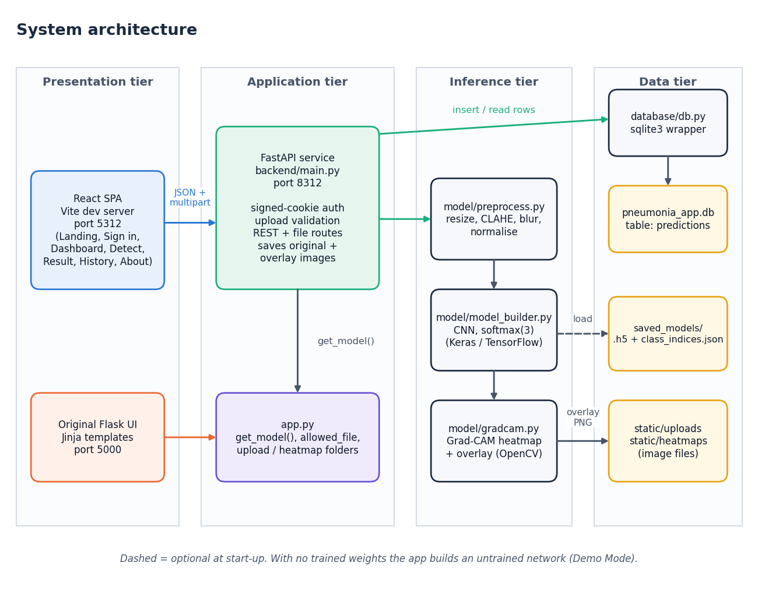
Figure 1: System architecture of the pneumonia detection system
The system has four tiers. In the presentation tier the React single-page application (served by the Vite development server on port 5312) and the original Flask interface (port 5000) are the two ways a user reaches the system. The application tier is the FastAPI service in backend/main.py (port 8312), which authenticates the session cookie, validates uploads and exposes the REST and file routes; it imports app.py for the model loader and folder settings, so the model is loaded once and shared. The inference tier is the three modules that do the actual work: preprocess.py turns an upload into a 224 x 224 tensor, model_builder.py defines the CNN and gradcam.py produces the heat map. The data tier holds the SQLite database (pneumonia_app.db, table predictions), the saved original and overlay images, and the trained weights. When saved_models/ holds no weights the loader builds an untrained network and flags Demo Mode.

5.2 High-level workflow
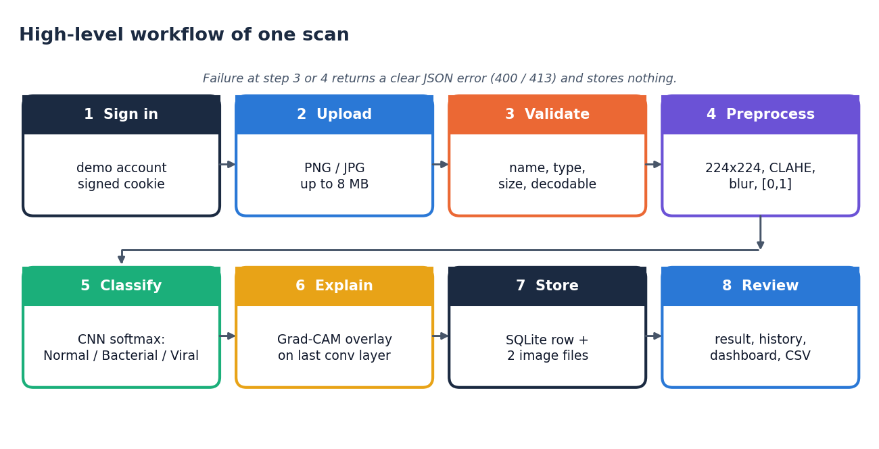
Figure 2: High-level workflow of one scan, from sign-in to review
A scan passes through eight steps. The user signs in, uploads a PNG or JPEG of at most 8 MB, and the server validates the name, type, size and that the file can be decoded. The image is preprocessed (224 x 224, CLAHE, light blur, scaling to [0, 1]) and classified by the CNN, whose softmax output gives the three class probabilities. Grad-CAM then explains the predicted class, and the record plus the two image files are stored. Finally the user reviews the result, the history and the dashboard. A failure at the validation or decoding step ends the flow with a JSON error and stores nothing.

5.3 Data flow diagrams

Level 0
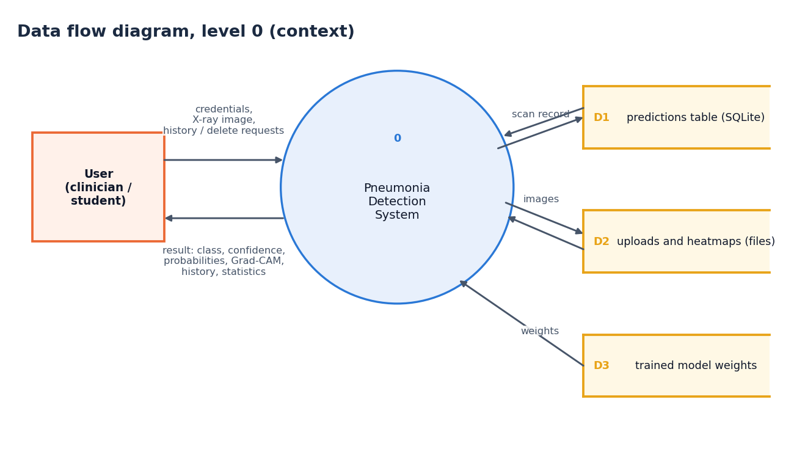
Figure 3: Data flow diagram, level 0 (context diagram)
The context diagram shows the system as a single process with one external entity, the user. The user sends credentials, X-ray images and history or delete requests; the system returns the classification result with its heat map, the history and the statistics. Internally the system reads and writes three data stores: the predictions table (D1), the uploaded and heat-map image files (D2) and the trained model weights (D3), which are only read.

Level 1
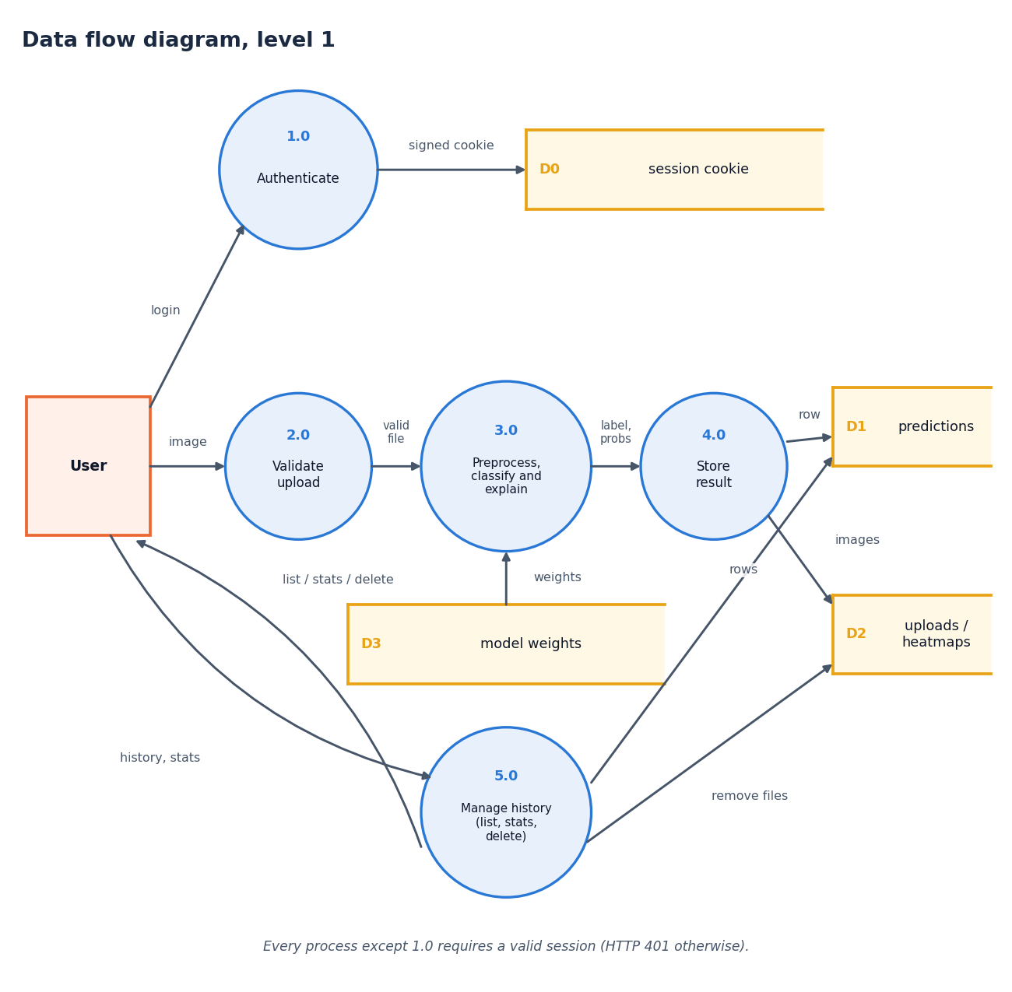
Figure 4: Data flow diagram, level 1
Level 1 splits the system into five processes. Authenticate (1.0) checks the credentials and sets a signed cookie (D0). Validate upload (2.0) accepts the image only if the cookie is valid, the extension is allowed, the size is within 8 MB and the file decodes. Preprocess, classify and explain (3.0) reads the model weights (D3) and returns the label, probabilities and overlay. Store result (4.0) writes one row to the predictions table (D1) and the two images to the file store (D2). Manage history (5.0) serves the list, the statistics and deletions, and removes the image files when a scan is deleted.

Level 2
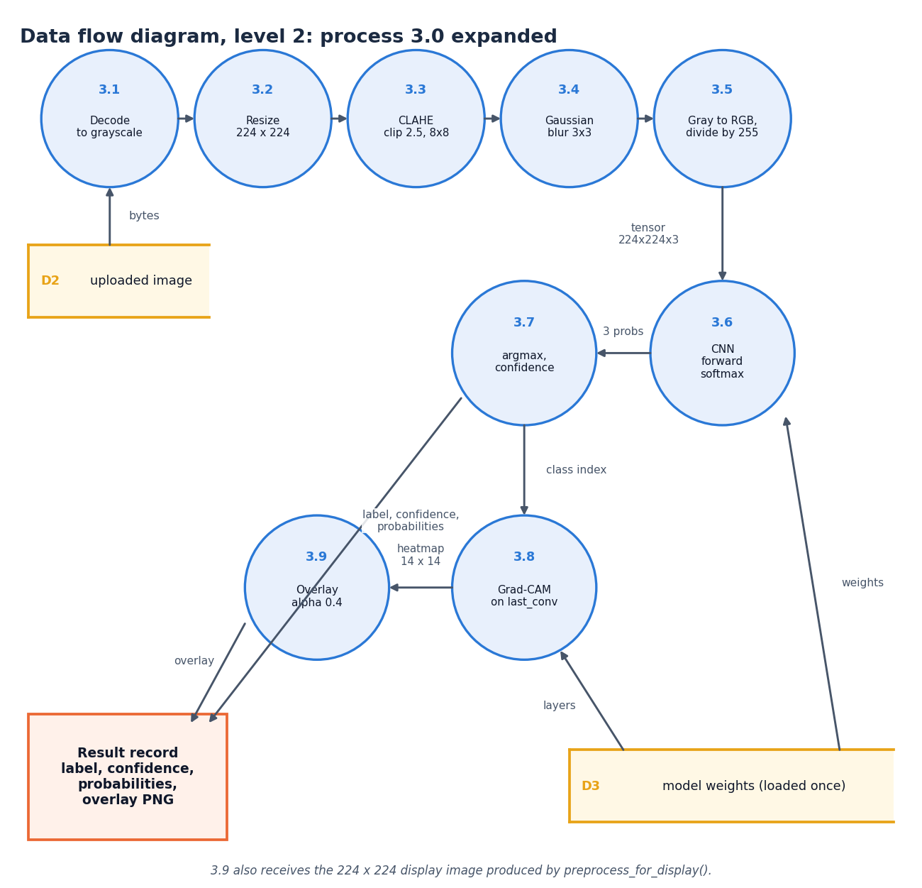
Figure 5: Data flow diagram, level 2: process 3.0 expanded
Level 2 expands the inference process into its nine steps, in the order the code executes them. The upload is decoded to grayscale (3.1), resized to 224 x 224 (3.2), enhanced with CLAHE (clip limit 2.5, 8 x 8 tiles; 3.3), smoothed with a 3 x 3 Gaussian (3.4) and converted to three channels scaled to [0, 1] (3.5). The network produces three probabilities (3.6); the arg-max and its probability become the label and confidence (3.7). The class index drives Grad-CAM on the last convolutional layer (3.8), whose 14 x 14 map is blended at alpha 0.4 over the display image (3.9). The result record carries the label, confidence, probabilities and the overlay image.

5.4 UML diagrams

Class diagram
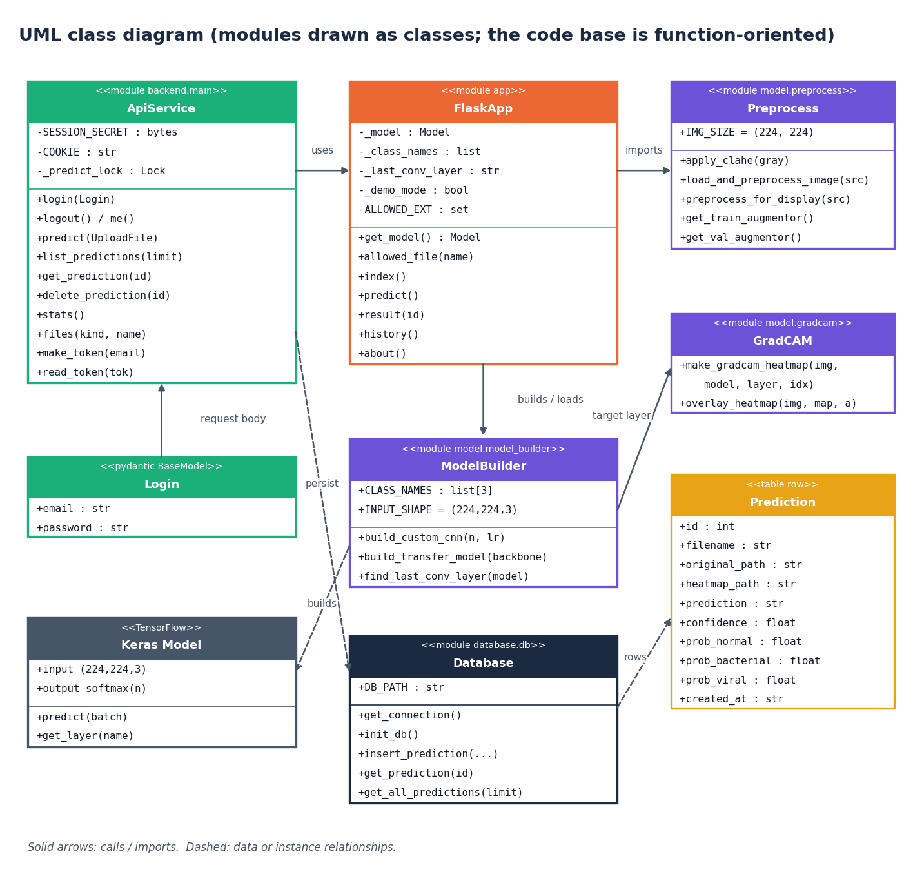
Figure 6: UML class diagram (modules drawn as classes)
The code base is function-oriented, so the diagram draws each Python module as a class stereotyped as a module, listing its constants and public functions. ApiService (backend/main.py) uses FlaskApp (app.py) for the model loader and imports Preprocess; FlaskApp builds or loads the network through ModelBuilder, which creates Keras models, and GradCAM receives the name of the last convolutional layer from ModelBuilder. Database persists Prediction rows. Login is the only real class in the API layer (a Pydantic model that validates the sign-in body).

Sequence diagram
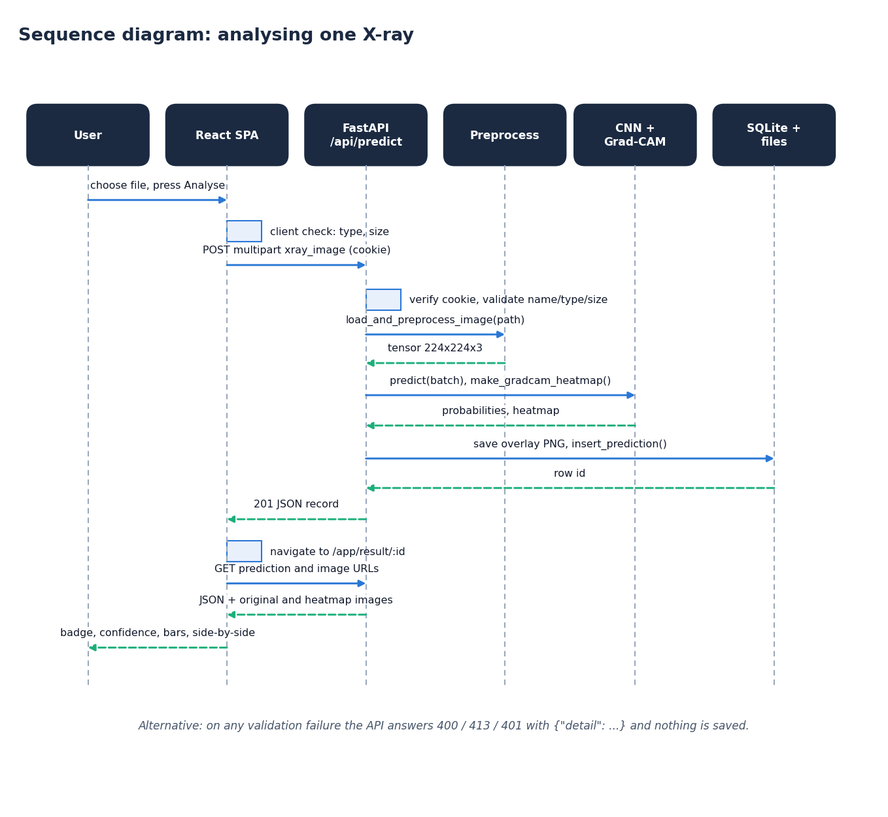
Figure 7: Sequence diagram: analysing one X-ray
The sequence follows one analysis. The React page checks the file type and size, then posts it as multipart data with the session cookie. The API verifies the cookie and validates the upload, calls the preprocessing function, and, under a lock that allows one TensorFlow inference at a time, runs the network and Grad-CAM. It writes the overlay image and the database row and returns HTTP 201 with the full record. The page then navigates to the result route, which fetches the record and the two images and renders the badge, confidence, bars and side-by-side view.

Use-case diagram
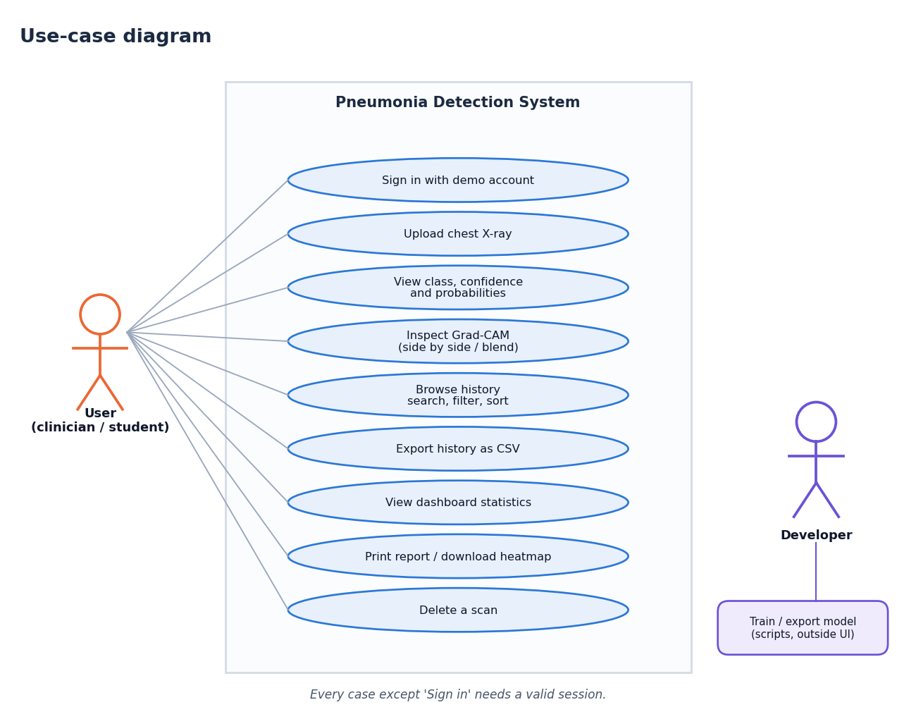
Figure 8: Use-case diagram
The user can sign in, upload an X-ray, view the class, confidence and probabilities, inspect the Grad-CAM overlay (side by side or blended), browse and filter the history, export it as CSV, view dashboard statistics, print the report or download the heat map, and delete a scan. Every case except signing in requires a valid session. The developer is a second actor who trains and exports a model with the scripts, outside the web interface.

Core algorithm flowchart
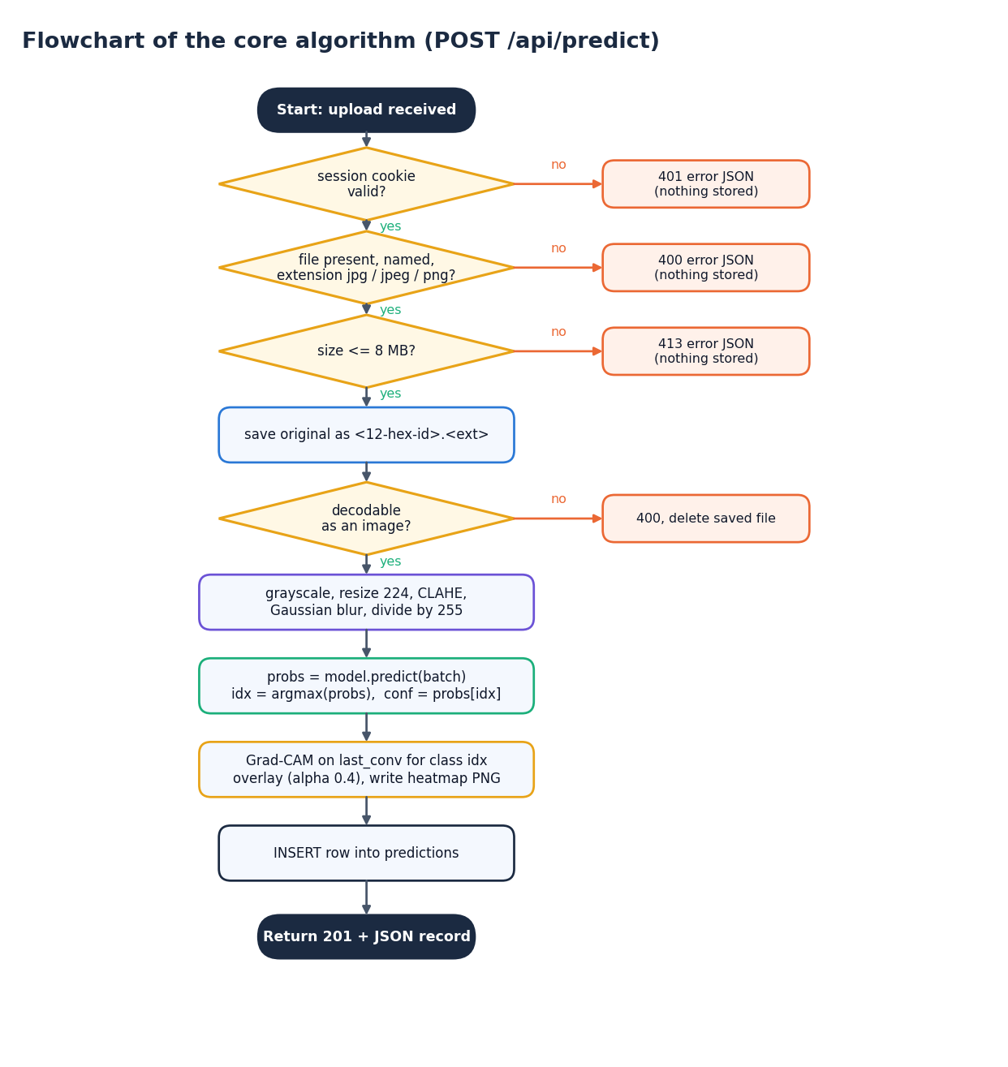
Figure 9: Flowchart of the core algorithm (POST /api/predict)
The flowchart gives the decisions of the prediction route in order: valid session (401 otherwise), a named file with an allowed extension (400), size within 8 MB (413), save under a random 12-character name, decodable image (400, and the saved file is deleted). It then preprocesses, predicts, takes the arg-max, runs Grad-CAM, writes the overlay, inserts the row and returns 201 with the record. The order matches backend/main.py and the Flask route.

5.5 Database design
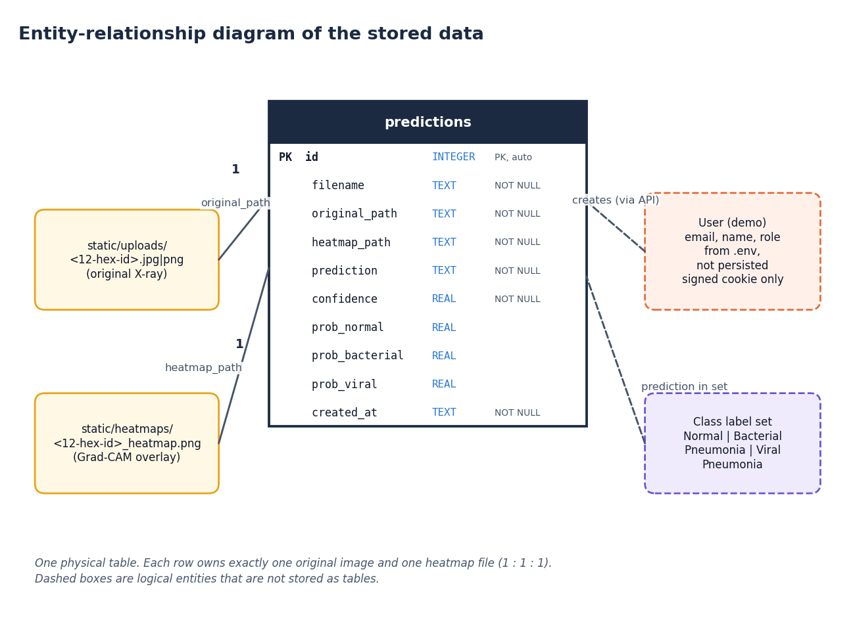
Figure 10: Entity-relationship diagram of the stored data
All persistent data are in one table, predictions, with ten columns. Each row owns exactly one original image in static/uploads/ and one overlay in static/heatmaps/, referenced by relative path, so the relationship between a row and its files is one to one to one. The demo user and the class label set are logical entities: the user is configured through the environment and carried only in a signed cookie, and the label set is the fixed list of three class names.
Table 11: Table predictions
Column | Type | Constraint | Meaning
id | INTEGER | Primary key, auto-increment | Scan number shown in the interface
filename | TEXT | NOT NULL | Original file name as uploaded
original_path | TEXT | NOT NULL | Relative path of the saved original, e.g. uploads/ab12cd34ef56.jpg
heatmap_path | TEXT | NOT NULL | Relative path of the Grad-CAM overlay, e.g. heatmaps/ab12cd34ef56_heatmap.png
prediction | TEXT | NOT NULL | Predicted class name
confidence | REAL | NOT NULL | Probability of the predicted class, 0 to 1
prob_normal | REAL |  | Softmax probability of Normal
prob_bacterial | REAL |  | Softmax probability of Bacterial Pneumonia
prob_viral | REAL |  | Softmax probability of Viral Pneumonia
created_at | TEXT | NOT NULL | UTC timestamp in ISO-8601 form

The table is created by init_db() with CREATE TABLE IF NOT EXISTS, so a fresh checkout needs no migration. All statements use bound parameters (?), never string formatting, which removes SQL injection through file names or ids.

5.6 Module design
Table 12: Modules and responsibilities
Module | Responsibility | Key functions
model/preprocess.py | Image preparation | load_and_preprocess_image, apply_clahe, preprocess_for_display, augmentors
model/model_builder.py | Network definition | build_custom_cnn, build_transfer_model, find_last_conv_layer, CLASS_NAMES
model/gradcam.py | Explanation | make_gradcam_heatmap, overlay_heatmap
model/train.py | Original training script (unchanged) | Keras generators, checkpoint, report
scripts/train_experiment.py | Reproducible experiment runner | patient-level split, class weights, metrics.json, figures
database/db.py | Persistence | init_db, insert_prediction, get_prediction, get_all_predictions
app.py | Original Flask app and model loader | get_model, allowed_file, routes /, /predict, /result/<id>, /history, /about
backend/main.py | FastAPI layer | auth routes, /api/predict, /api/predictions, /api/stats, /api/files, /api/health
frontend/src/pages/* | React screens | Landing, Login, Dashboard, Detect, Result, History, About, NotFound
frontend/src/lib/* | Client logic | api.js (fetch and upload progress), auth.jsx, theme.jsx, format.js, hooks.js
tests/, scripts/*.py | Verification | 73 pytest tests, smoke test, UI verification, screenshot capture

5.7 API design
The API is JSON over HTTP. Errors use the standard FastAPI body {"detail": "message"} with 400 for bad input, 401 for a missing or invalid session, 404 for unknown ids or files and 413 for oversize uploads. The validation order of /api/predict matches the original Flask route, so the same mistake produces the same message in both interfaces.
Table 13: REST endpoints
Method | Path | Session | Purpose
GET | /api/health | No | Status, model readiness, Demo Mode flag, class names, upload limits
POST | /api/auth/login | No | Demo sign-in; sets the signed HttpOnly cookie
POST | /api/auth/logout | No | Clears the cookie
GET | /api/auth/me | No | Signed-in user, or null when signed out
POST | /api/predict | Yes | Multipart xray_image; returns the stored record (201)
GET | /api/predictions?limit= | Yes | History, newest first (limit clamped to 1-1000)
GET | /api/predictions/{id} | Yes | One record; 404 JSON if missing
DELETE | /api/predictions/{id} | Yes | Removes the row and both image files
GET | /api/stats | Yes | Totals, per-class counts, average confidence, 7-day series
GET | /api/files/{uploads|heatmaps}/{name} | Yes | Stored images; basename check blocks traversal

5.8 User interface design
The interface uses the Neo Brutal Grid design kit: thick black outlines, hard offset shadows, a visible grid, an uppercase display typeface for headings and a monospace face for numbers. Colour carries meaning: green for Normal, coral for Bacterial Pneumonia and amber for Viral Pneumonia, and every colour is paired with a label and an icon so the meaning never depends on colour alone. The application shell has a sidebar that becomes a drawer on small screens, a theme toggle that remembers its setting, toast messages, skeleton placeholders and a 404 route.
Table 14: Screens
Screen | Content
Landing / | Public introduction: hero, how it works, the three classes, key figures, disclaimer, call to action
Sign in /login | Demo credentials with a one-click fill button and a show-password option
Dashboard /app | Stat cards, class-distribution and scans-per-day charts, recent scans
Detect /app/detect | File drop area, preview, analyse button with progress, validation messages, Demo Mode alert
Result /app/result/:id | Side-by-side and blended views, class badge, probability bars, scan details, print, download, delete
History /app/history | Search, class filter, sortable paginated table with thumbnails, CSV export, empty state
About /app/about | Abstract, five-step pipeline, technology, disclaimer
Not found * | Friendly 404 with a way back

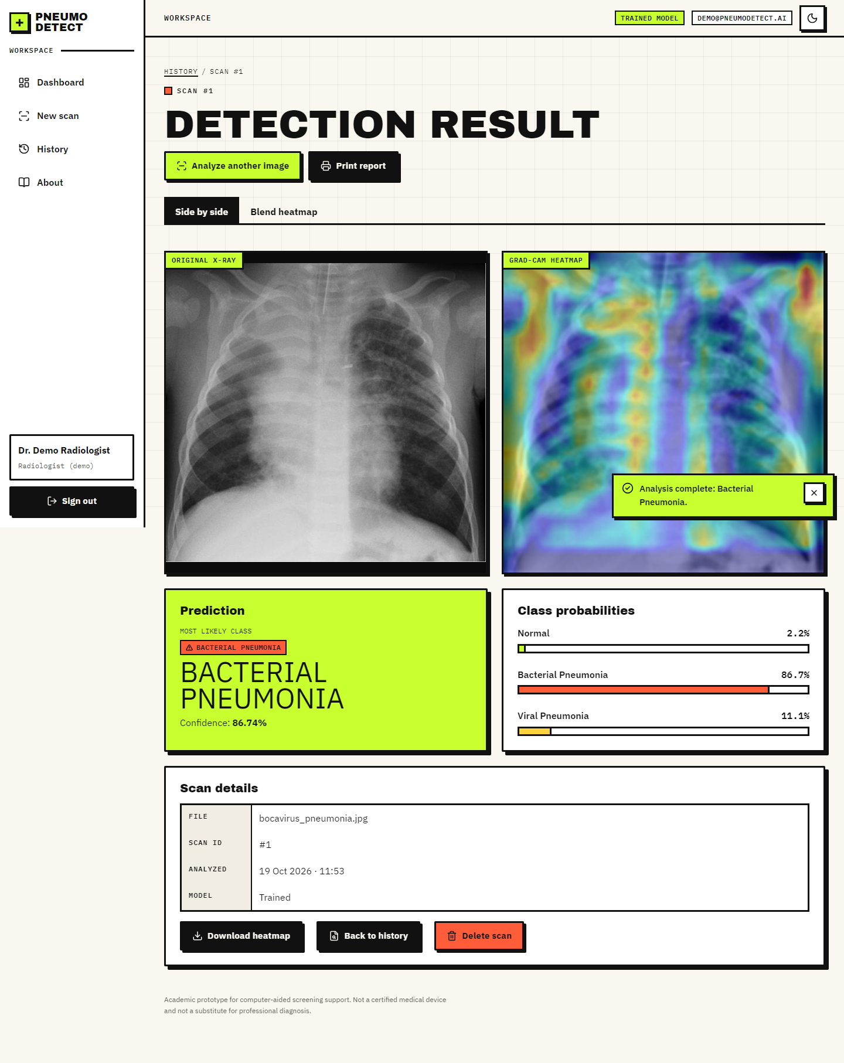
Figure 11: The result screen: side-by-side original and Grad-CAM overlay, class badge and probabilities
Accessibility was designed in rather than added later: visible focus rings, a focus trap in dialogs, the Escape key closing the mobile drawer and the delete dialog, announced loading states, and a reduced-motion mode that keeps all content visible. Chapter 7 reports the automated checks of these properties.

CHAPTER 6: METHODOLOGY AND SOFTWARE IMPLEMENTATION

6.1 Overall methodology
The method has two phases that share one preprocessing function. In the training phase the public chest X-ray data are listed, labelled from their folder and file names, preprocessed, split by patient into training and validation parts, augmented and used to fit the CNN; the best weights are evaluated once on the untouched test split and every number is written to JSON. In the inference phase an uploaded image goes through the same preprocessing, the saved network returns three probabilities, Grad-CAM explains the arg-max class, and the result is stored and displayed.
Figure 12: Overall workflow used at inference time (the same preprocessing is used for training)

6.2 Dataset
The data are the Chest X-Ray Images (Pneumonia) collection of Kermany et al. [3], [4]: paediatric (one to five years) anterior-posterior chest radiographs from the Guangzhou Women and Children's Medical Center, released under CC BY 4.0. The version used has 5,856 JPEG images in the official folders train (5,216), val (16) and test (624). Pneumonia images carry the pathogen in the file name (person12_bacteria_34.jpeg, person7_virus_21.jpeg), which gives the three project classes.
Table 15: Official folders and the three project classes
Folder | Normal | Bacterial | Viral | Total
train | 1,341 | 2,530 | 1,345 | 5,216
val | 8 | - | - | 16 (8 normal, 8 pneumonia)
test | 234 | 242 | 148 | 624

The official validation folder holds only 16 images, too few to guide training. The experiment script therefore merges train and val and cuts a validation set of about 10 % by patient (a stratified group split, seed 42), so that images of one patient never appear on both sides. The official test folder is used once, for the final evaluation. A further check (Section 8.4) shows that many pneumonia file ids in the test folder also occur in the training folders, a property of the public data that earlier work has also reported; the report therefore also gives results on the part of the test split that shares no id with training and on a fully patient-disjoint re-partition.
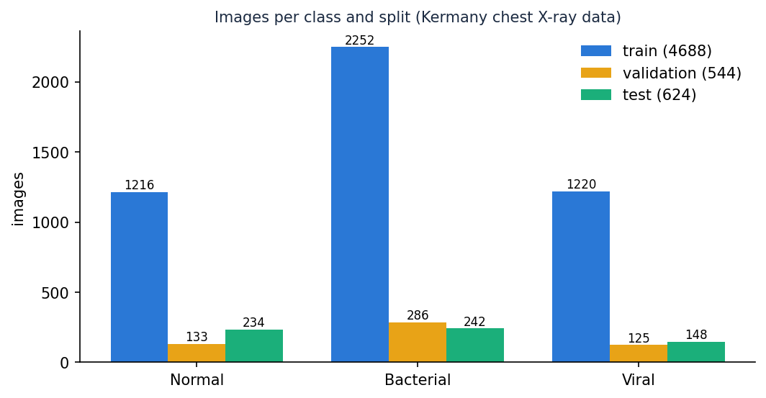
Figure 13: Images per class in the training, validation and test sets used by the main experiment

6.3 Preprocessing
The function load_and_preprocess_image in model/preprocess.py is used unchanged by the training script, the Flask route and the FastAPI route:
1. Decode the file as a single-channel grayscale image (cv2.imread or cv2.imdecode); a file that cannot be decoded raises ValueError, which the API turns into HTTP 400.
2. Resize to 224 x 224 with area interpolation, the input size of the network and of the ImageNet backbones.
3. Apply CLAHE, contrast-limited adaptive histogram equalisation [11], with clip limit 2.5 and 8 x 8 tiles, to bring out lung markings.
4. Apply a 3 x 3 Gaussian blur to suppress scanner and JPEG noise.
5. Replicate the channel three times and divide by 255 to obtain a float32 tensor in [0, 1] of shape 224 x 224 x 3.
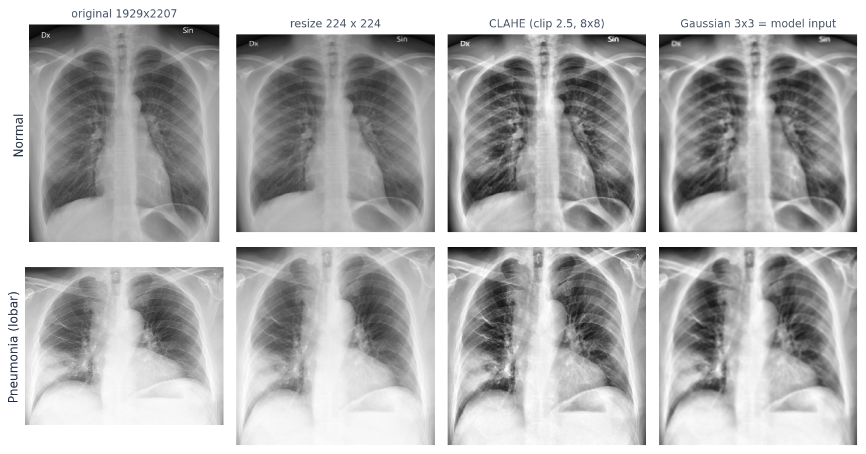
Figure 14: Preprocessing steps applied to a normal and a pneumonia radiograph (public-domain sample images)
During training, augmentation is applied on top of the preprocessed image: rotation up to 12 degrees, horizontal and vertical shifts of 8 %, shear of 8 %, zoom of 12 % and horizontal flips, with nearest-neighbour filling. These are the ranges of get_train_augmentor in the original code. The base paper disables flips to preserve anatomical orientation [1]; the project's augmentor keeps them, which is recorded as a design difference.

6.4 Algorithm choice and justification
Table 16: Choices and reasons
Decision | Choice | Reason
Model family | CNN written for the project (4 convolution blocks) | Small (0.59 M parameters), trains on a CPU, no external weights, easy to explain; a transfer-learning builder is also provided
Normalisation | Batch normalisation after each convolution | Stabilises training of a network trained from scratch [17]
Pooling before the head | Global average pooling | Fewer parameters than flattening and keeps spatial meaning for Grad-CAM
Regularisation | Dropout 0.35 and 0.25, data augmentation, early stopping | Small data and a risk of over-fitting [18]
Loss | Categorical cross-entropy with balanced class weights | Bacterial images are about twice as frequent as the other classes
Optimiser | Adam, learning rate 3e-4 (baseline run: 1e-4) | Adaptive and robust for a first experiment [16]
Explanation | Grad-CAM on the last convolution layer | Works on any CNN without changing it [9]; the layer is named last_conv
Contrast step | CLAHE | Standard for radiographs [11]; its effect is measured by an ablation (Chapter 8)

6.5 Mathematical formulation
Convolution block. For the input feature map A(l-1), learned kernels W(l) and biases b(l), each block applies a convolution, the ReLU non-linearity, batch normalisation and 2 x 2 max pooling.
A(l) = MaxPool( BN( ReLU( W(l) * A(l-1) + b(l) ) ) ), ReLU(x) = max(0, x) (1)
BN(x) = γ · (x − μB) / √(σB² + ε) + β (2)
Classifier. Global average pooling turns each of the 256 final feature maps into one number; two dense layers follow and the output layer produces three logits z, which the softmax converts into probabilities. The predicted class is the arg-max and the reported confidence is its probability.
gk = (1 / HW) · Σi Σj Ak(i, j) (3)
pc = exp(zc) / Σj=1..3 exp(zj), ĉ = argmax pc, confidence = pĉ (4)
Loss. With balanced class weights (N images, K = 3 classes, nc images in class c) the weighted cross-entropy over a batch of B images is:
wc = N / (K · nc) (5)
L = − (1 / B) · Σi=1..B w(yi) · Σc yic · log pic (6)
Optimiser. Adam keeps exponential moving averages of the gradient (mt) and of its square (vt) and updates the parameters with learning rate η (3 × 10-4 for the deployed model, 10-4 for the baseline run):
θt = θt-1 − η · m̂t / ( √v̂t + ε ) (7)
Grad-CAM. For class c and the last convolutional feature maps Ak, the channel weights are the spatially averaged gradients of the class score, and the map is the rectified weighted sum of the feature maps, normalised by its maximum, resized to 224 x 224, coloured with the JET colour map H and blended with the display image I (code: overlay_heatmap, alpha 0.4):
αkc = (1 / Z) · Σi Σj ∂yc / ∂Ak(i, j), Lc = ReLU( Σk αkc · Ak ) (8)
O = 0.6 · I + 0.4 · H (9)
Metrics. From the confusion matrix, with TP, TN, FP and FN counted for the class (or for pneumonia against normal in the binary view):
accuracy = (TP + TN) / N, precision = TP / (TP + FP), recall = sensitivity = TP / (TP + FN) (10)
specificity = TN / (TN + FP), F1 = 2 · precision · recall / (precision + recall), macro-F1 = mean of the three class F1 (11)
Calibration is summarised by the expected calibration error with M = 10 equal-width confidence bins [29], where acc(Bm) and conf(Bm) are the accuracy and mean confidence of the images in bin m. A confidence threshold τ keeps a prediction for automatic reporting only if its confidence is at least τ; coverage is the share of scans kept:
ECE = Σm=1..M (|Bm| / n) · | acc(Bm) − conf(Bm) |, coverage(τ) = #{ i : pĉ,i ≥ τ } / n (12)

6.6 Model architecture and training
The deployed architecture is build_custom_cnn from model/model_builder.py. The input is 224 x 224 x 3. Four convolution blocks (3 x 3 kernels with 32, 64, 128 and 256 filters, each followed by batch normalisation and 2 x 2 max pooling) are followed by global average pooling, a 512-unit dense layer with batch normalisation and dropout 0.35, a 128-unit dense layer with dropout 0.25 and a three-unit softmax output. The last convolution layer is named last_conv so that Grad-CAM can find it.
Table 17: Layers of the deployed network
Layer | Type | Output shape | Parameters
input_layer | InputLayer | 224x224x3 | 0
conv2d | Conv2D | 224x224x32 | 896
batch_normalization | BatchNormalization | 224x224x32 | 128
max_pooling2d | MaxPooling2D | 112x112x32 | 0
conv2d_1 | Conv2D | 112x112x64 | 18,496
batch_normalization_1 | BatchNormalization | 112x112x64 | 256
max_pooling2d_1 | MaxPooling2D | 56x56x64 | 0
conv2d_2 | Conv2D | 56x56x128 | 73,856
batch_normalization_2 | BatchNormalization | 56x56x128 | 512
max_pooling2d_2 | MaxPooling2D | 28x28x128 | 0
last_conv | Conv2D | 28x28x256 | 295,168
batch_normalization_3 | BatchNormalization | 28x28x256 | 1,024
max_pooling2d_3 | MaxPooling2D | 14x14x256 | 0
global_average_pooling2d | GlobalAveragePooling2D | 256 | 0
dense | Dense | 512 | 131,584
batch_normalization_4 | BatchNormalization | 512 | 2,048
dropout | Dropout | 512 | 0
dense_1 | Dense | 128 | 65,664
dropout_1 | Dropout | 128 | 0
dense_2 | Dense | 3 | 387

The network has 590,019 parameters (588,035 trainable), about 2.36 MB in 32-bit floats.
The original model/train.py fits the same network with a Keras directory generator and rescaling only. The experiment script scripts/train_experiment.py (used for every number in this report) differs in four ways: it applies the inference preprocessing (CLAHE and blur) during training, so the network is trained on what it will see in service; it splits validation data by patient; it uses balanced class weights; and it records metrics, predictions and figures.
Table 18: Training configuration of the main experiment
Setting | Value
Architecture | build_custom_cnn(num_classes=3)
Input | 224 x 224 x 3, CLAHE + blur preprocessing
Optimiser / loss | Adam, learning rate 0.0003; categorical cross-entropy with balanced class weights
Batch size / maximum epochs | 32 / 40
Callbacks | Early stopping on validation loss (patience 10, best weights restored); learning rate halved after 3 epochs without improvement
Augmentation | Rotation 12, shift 0.08, shear 0.08, zoom 0.12, horizontal flip
Random seed | 42
Hardware | Intel Core i5-12500 CPU, no GPU; about 214 seconds per epoch

Baseline run and recipe change (disclosure). The first run used the project's defaults (Adam 1e-4, early-stopping patience 6, at most 25 epochs). It stopped after 12 epochs with its best validation loss at epoch 6: the validation loss of a batch-normalised network trained from scratch is noisy, early stopping fired before the network had converged, and training accuracy was only about 74 %. The recipe was then changed to a higher learning rate (3e-4), a longer patience (10) and up to 40 epochs. This change was made after the baseline's test result had been seen, so both runs are reported side by side (Section 8.5); the choice of the deployed model between them rests on the validation set, not on the test split.
Transfer-learning option and a limitation found while testing it. build_transfer_model offers DenseNet201, DenseNet121, ResNet152V2 and EfficientNetB0 backbones. When a backbone is nested inside the model, make_gradcam_heatmap cannot connect the nested feature tensor to the outer input and raises an error; the shipped Grad-CAM therefore works only with the flat custom CNN, which is why the custom CNN is the deployed model. Chapter 8 includes a MobileNetV3Small experiment (the base paper's backbone) for comparison, without Grad-CAM.

6.7 Application architecture
backend/main.py creates a FastAPI application (api) whose start-up hook initialises the database and loads the model in a background thread so the first request does not pay the loading cost. It imports app.py and calls get_model() so that the Flask and FastAPI interfaces share one loader, one set of folders and one _demo_mode flag. A threading lock allows only one TensorFlow inference at a time. Cross-origin requests are accepted only from the front-end origin (http://localhost:5312). The React application talks to /api/* through the Vite proxy, so the browser sees one origin and the session cookie is first-party.
The front end is a single-page application built with React 19 and Vite. Routes are code-split and lazy-loaded (the chart library is loaded only by the dashboard). lib/api.js wraps fetch, turns every error response into an ApiError with the server's message and uses an XMLHttpRequest for uploads so the progress bar can show real upload progress; a 401 anywhere returns the user to the sign-in page.

6.8 API design
Section 5.7 lists the ten endpoints. The prediction route validates in a fixed order (no file, empty name, unsupported extension, size above 8 MB, unreadable image), saves the original under a random 12-character name, preprocesses, runs the network and Grad-CAM under the lock, writes the overlay, inserts the database row and returns the stored record with status 201. The record contains the probabilities as an object keyed by class name, image URLs under /api/files/, an ISO timestamp with a trailing Z and the demo_mode flag.
@api.post("/api/predict", status_code=201)
def predict(xray_image: UploadFile = File(None), user=Depends(current_user)):
if xray_image is None: bad(400, "No file part in the request.")
if not xray_image.filename: bad(400, "Please choose an X-ray image to upload.")
if not flask_app.allowed_file(xray_image.filename):
bad(400, "Unsupported file type. Please upload a JPG or PNG image.")
data = xray_image.file.read(MAX_BYTES + 1)
if len(data) > MAX_BYTES: bad(413, "File is too large. The limit is 8 MB.")
...
with _predict_lock:
probs = model.predict(batch, verbose=0)[0]
pred_idx = int(np.argmax(probs))
heatmap, _ = make_gradcam_heatmap(batch, model, flask_app._last_conv_layer, pred_index=pred_idx)
...
return serialize(db.get_prediction(pred_id))

6.9 Security and error handling
Table 19: Controls
Threat or fault | Control in the code
Unauthenticated access | Every route except health, login, logout and /api/auth/me depends on current_user, which reads a signed cookie and answers 401
Cookie forgery or tampering | Cookie = base64 payload + HMAC-SHA256 signature checked with hmac.compare_digest; payload carries an expiry (12 h)
Script access to the session | Cookie set HttpOnly and SameSite=Lax
Path traversal on file routes | Only uploads and heatmaps are served and the name must equal its own basename
SQL injection | All SQL uses bound parameters
Hostile or huge uploads | Extension allow-list, 8 MB limit read incrementally (413), decode check (400) with deletion of the saved file
Concurrent inference | A lock serialises TensorFlow calls
Cross-site requests | CORS limited to the front-end origin, credentials allowed only for it
Credentials in source control | .env is git-ignored; .env.example documents the variables; the demo password is shown on the sign-in page because it is a demonstration account
Unreadable or missing model | The loader builds an untrained network and the interface shows a Demo Mode warning on every relevant screen

Known weaknesses are stated in Section 1.8: the demo account is shared, the transport is plain HTTP on localhost, and the original Flask application keeps a fixed secret key and no login.

6.10 Installation and execution
run.bat reads the ports from .env (API 8312, UI 5312), creates a .venv if needed, installs requirements.txt and requirements-api.txt, runs npm install in frontend/ on first use, opens two console windows (the API and the UI) and then the browser. stop.bat closes them. run.bat flask starts the original Flask interface on port 5000. Appendix B gives the full user guide and the manual commands.

CHAPTER 7: SYSTEM TESTING

7.1 Testing strategy
Testing follows the structure of the system. Small, deterministic functions are covered by unit tests; the API is exercised end to end with the real model, a throw-away database and throw-away image folders; the original Flask pages have functional tests; the running stack is checked by a smoke test and by browser-driven verification of the interface. Every test starts from a clean temporary database, so tests cannot affect each other or the real history.
Table 20: Test layers
Layer | Tool | What it checks | Count
Unit | pytest | Preprocessing, network builder, Grad-CAM, database layer, session tokens | 31
Integration | pytest + FastAPI TestClient | Authentication, validation, prediction, history, statistics, file serving through the real model | 34
Functional (original UI) | pytest + Flask test client | Upload form, result page, history, error messages | 8
System smoke | scripts/smoke_test.py (standard library only) | The running servers: login, 401s, validation, four real predictions, images, history, statistics, 404, delete, logout | 25 checks
User interface | scripts/verify_ui.py (Playwright) | Overflow and console errors at 360, 768 and 1440 px in light and dark; drawer, dialog, focus, theme persistence, reduced motion | 6 configurations

The automated suite contains 73 pytest tests, all of which passed in the final run (22 s).

7.2 Unit tests
Table 21: Unit tests
File | Tests | Examples
tests/test_preprocess.py | 10 | Output is 224 x 224 x 3 float32 in [0, 1]; channels identical; bytes and path give the same tensor; CLAHE raises the contrast of a flat image; unreadable input raises ValueError
tests/test_model_gradcam.py | 9 | Network output is a probability vector; last convolution layer found; Grad-CAM map normalised to [0, 1]; overlay keeps size and dtype; alpha 0 returns the original
tests/test_database.py | 7 | Initialisation is idempotent; ids increment; round trip of a record; newest-first order; limit; schema columns
tests/test_auth_tokens.py | 5 | Token round trip; tampered payload; tampered signature; expired token; malformed tokens

7.3 Integration tests
tests/test_api.py (34 tests) drives the FastAPI application in-process. It signs in, uploads the three public sample radiographs and checks the complete record: probabilities for the three classes sum to one, the label is the arg-max, the confidence equals the largest probability, both image URLs are served as images, the same image gives the same probabilities twice, uppercase .PNG uploads are accepted, history is newest first, statistics agree with history, and deleting a scan removes it.

7.4 Functional tests
tests/test_flask_app.py (8 tests) covers the original interface: the home page has the upload field, about and history render, an unknown result redirects home, a post without a file shows "No file part", a .gif is rejected, a valid upload redirects to a result page that shows the prediction and the Grad-CAM image and then appears in the history, and an oversize body is refused with 413.
scripts/smoke_test.py runs 25 checks against the live servers (through the Vite proxy when given the front-end address) and scripts/capture_screens.py walks every screen with real uploads, failing on any console error or HTTP 4xx/5xx; its output is the set of screenshots in Chapter 8.

7.5 Security tests
Table 22: Security checks
Check | Expected | Test
Protected routes without a session (6 routes) | 401 | test_protected_routes_need_a_session
Forged cookie abc.def | 401 | test_forged_cookie_is_rejected
Tampered payload or signature, expired token | Rejected | tests/test_auth_tokens.py
Wrong password, wrong email | 401 | test_login_rejects_*
Session cookie attributes | HttpOnly present | test_login_sets_httponly_cookie
Path traversal (..%2Fapp.py, ..%5Capp.py), unknown folder, missing file | 404 | test_files_route_blocks_missing_and_traversal
Corrupt image | 400 and the saved file removed | test_predict_rejects_corrupt_image_and_cleans_up
Upload larger than 8 MB | 413 | test_predict_rejects_oversize_upload

7.6 Validation and edge cases
• No file part, empty file name, extension missing, extension not allowed (.gif), uppercase extension.
• Unreadable image content with a valid extension.
• Eight-megabyte boundary: the server reads at most 8 MB + 1 byte before deciding.
• limit=0 on the history route is clamped to one record.
• Unknown prediction id on read and on delete returns JSON 404, and the interface shows a not-found state.
• Statistics on an empty history return zero totals, a null average confidence and a seven-day series of zeros.
• Same image twice gives the same probabilities (deterministic inference).

7.7 Performance testing
Latency was measured on the development machine (Intel Core i5-12500, no GPU) for the deployed model. Over 60 test images, one image at a time, preprocessing takes 27 ms on average, the network forward pass 63 ms and Grad-CAM with the overlay 110 ms, so the model-side pipeline takes about 200 ms per image. These are means over 60 images after three warm-up calls.
The end-to-end time of POST /api/predict through the running API (upload, validation, preprocessing, inference, Grad-CAM, two file writes and a database insert) was measured with 36 requests: mean 521 ms, median 466 ms, 95th percentile 895 ms and maximum 1020 ms. Reading the history (30 calls) took 8 ms on average and a result record 7 ms.

7.8 User acceptance
No formal acceptance test with clinicians or external users was carried out, and this report does not claim one. What was done instead is a requirements walk-through: every functional requirement of Section 4.3 was exercised by an automated check or by the screenshot walk, and the traceability is summarised below.
Table 23: Requirement traceability
Requirement | Evidence
FR1 sign in / out | test_login_*, test_logout_clears_session, screen 03
FR2, FR3 upload and validation | test_predict_rejects_*, client-side checks on screens 04 and 05
FR4 preview | Screen 05
FR5, FR6 classification and Grad-CAM | test_predict_returns_a_complete_record, test_gradcam_*, screen 06
FR7 result display | Screens 06, 07, 08
FR8 storage | test_predict_saves_both_images_and_serves_them, test_history_*
FR9, FR10 history and export | Screen 11, smoke test
FR11 delete | test_delete_removes_the_record, dialog check in verify_ui.py
FR12 dashboard | test_stats_*, screens 09 and 10
FR13 print and download | Result screen actions (print stylesheet; download link)
FR14 Demo Mode warning | Present when no trained weights exist (shown in the first release of the interface)
FR15 not found | test_unknown_prediction_is_404_json, screen 13
FR16, FR17 about and disclaimer | Screens 01 and 12
FR18 themes | Theme persistence check in verify_ui.py; screens 02, 08, 10

7.9 Limits of the testing done
• The tests prove that the software behaves as specified, not that the model is clinically useful; model quality is measured separately in Chapter 8 and only on one public data source.
• There is no load or concurrency test beyond the single-inference lock, and no long-running soak test.
• The user-interface checks run in one browser engine (Chromium); other browsers and assistive technologies were not tested.
• No penetration test or dependency audit was performed; the security tests cover the controls listed in Section 6.9 only.
• The tests run on Windows with the development Python environment; the freshly built .venv from requirements.txt was verified with the smoke test, not with the full pytest suite.

CHAPTER 8: RESULTS AND OUTPUT SCREENS

8.1 Output screens
The screens below are captures of the running application at 1440 x 900 pixels, taken by scripts/capture_screens.py after real scans had been uploaded through the interface (four public sample radiographs, so the history, dashboard and result pages hold real data). The script fails on any console error or failed request; none occurred.
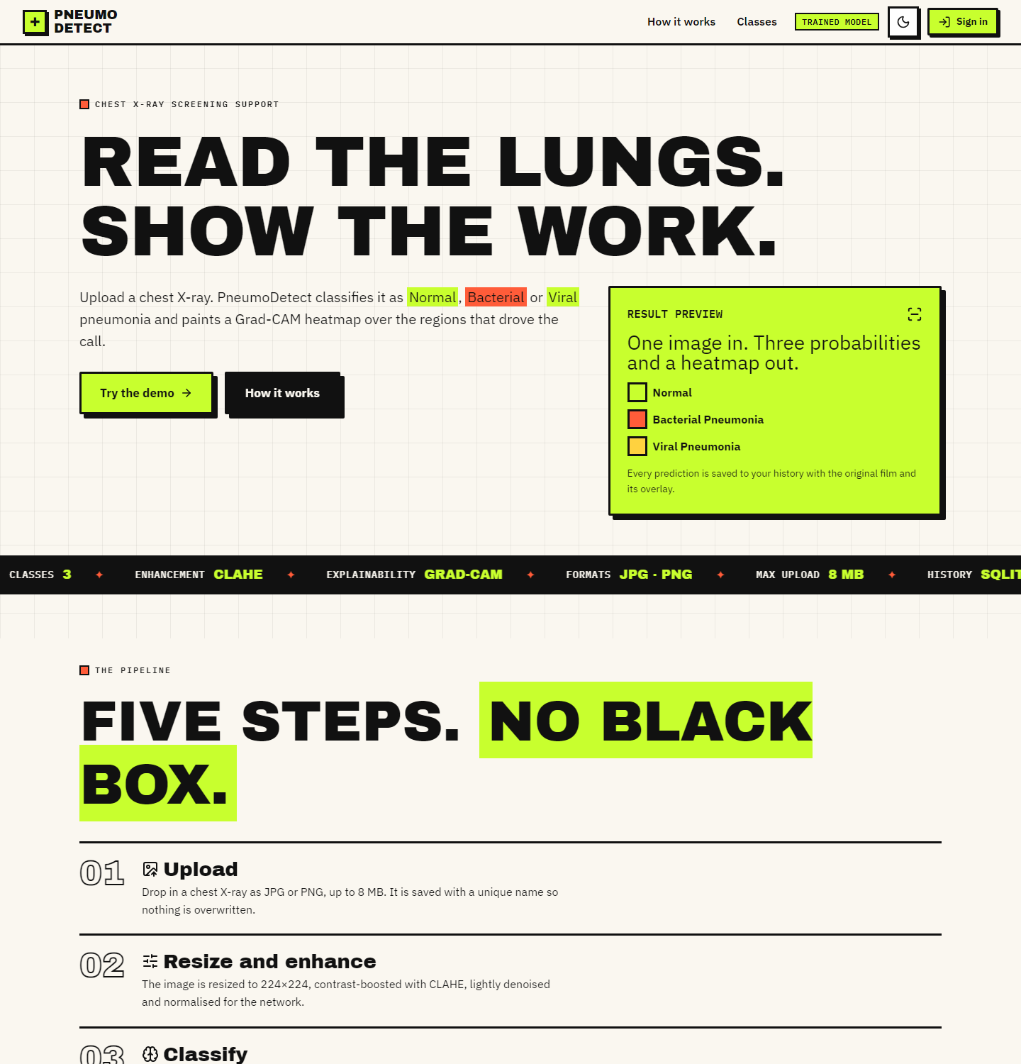
Figure 15: Landing page (light theme): hero, how the pipeline works, the three classes and the clinical disclaimer
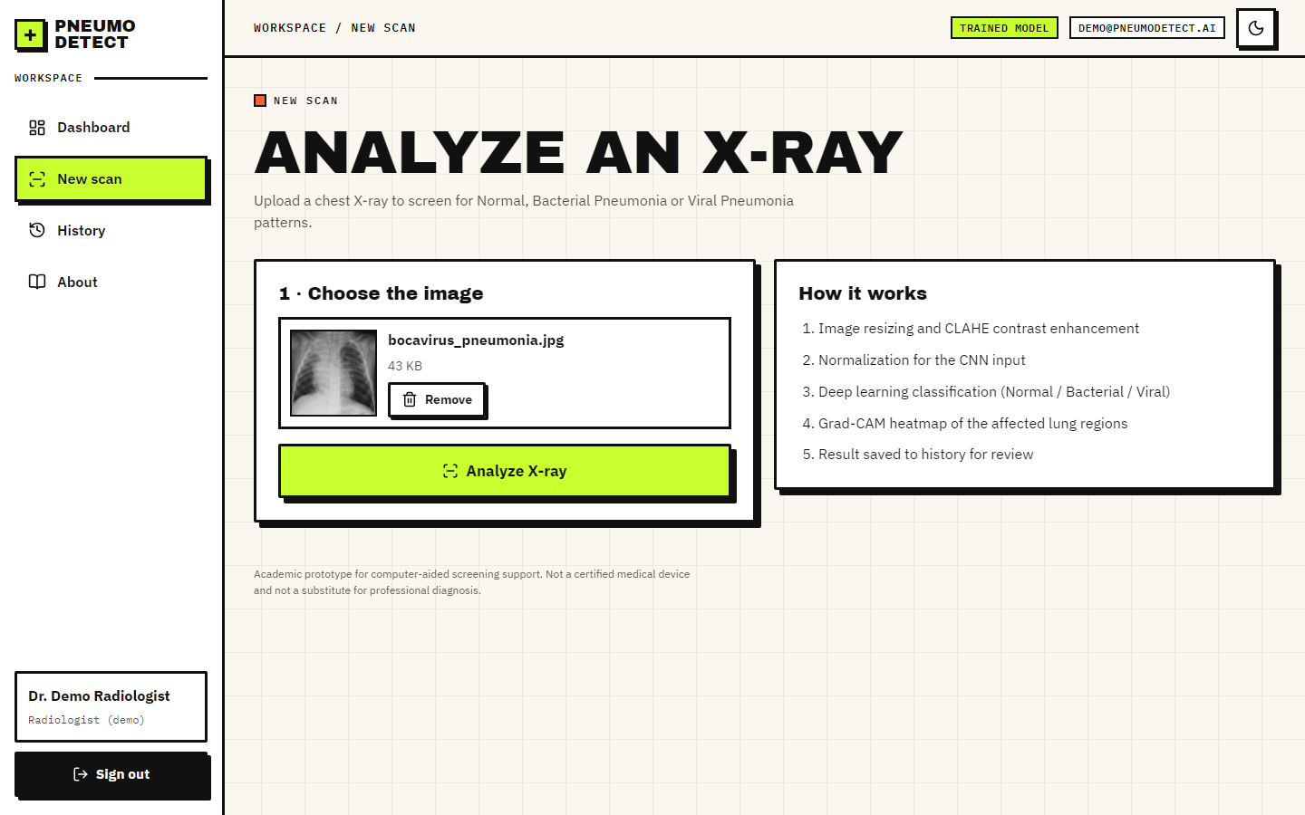
Figure 16: Detect screen with a preview of the selected radiograph and the Analyse button
Figure 17: Result screen: original X-ray beside the Grad-CAM overlay, class badge, confidence and the three probability bars
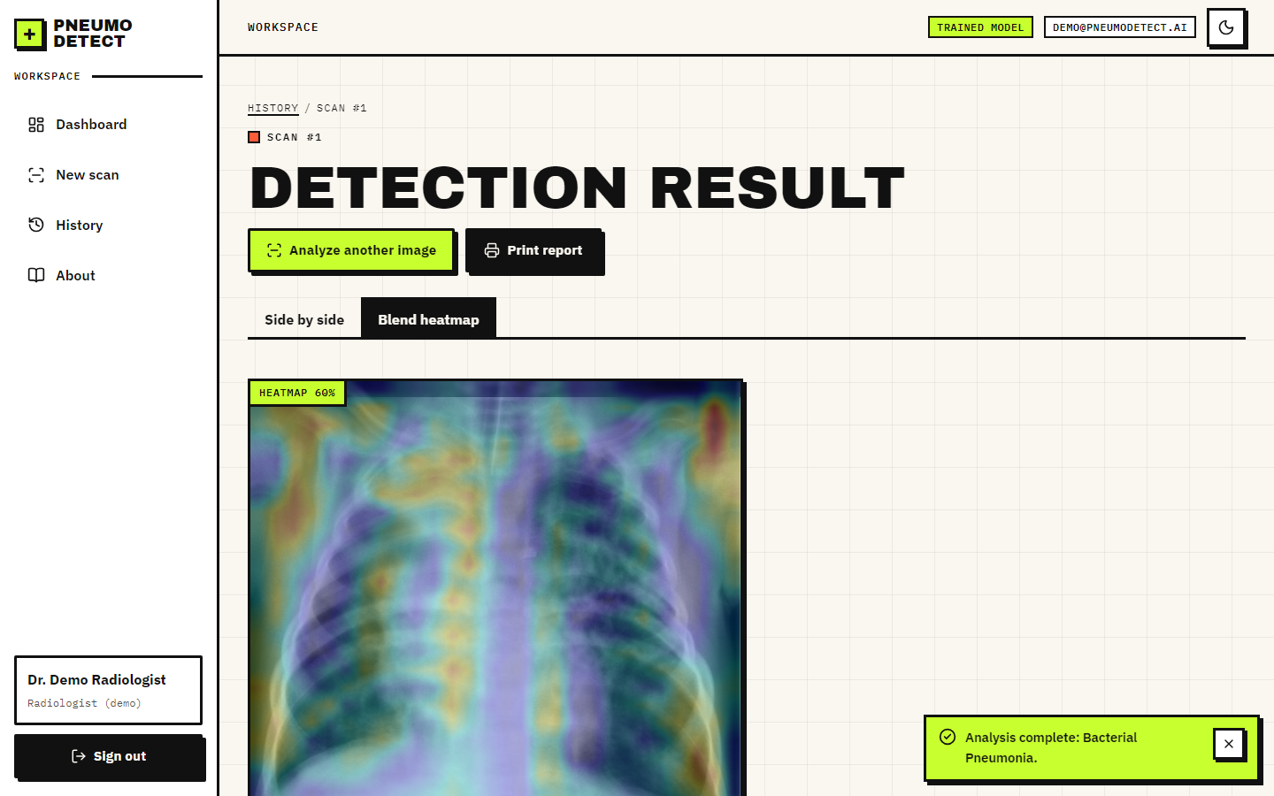
Figure 18: Result screen, blended view: a slider sets how strongly the heat map is laid over the X-ray
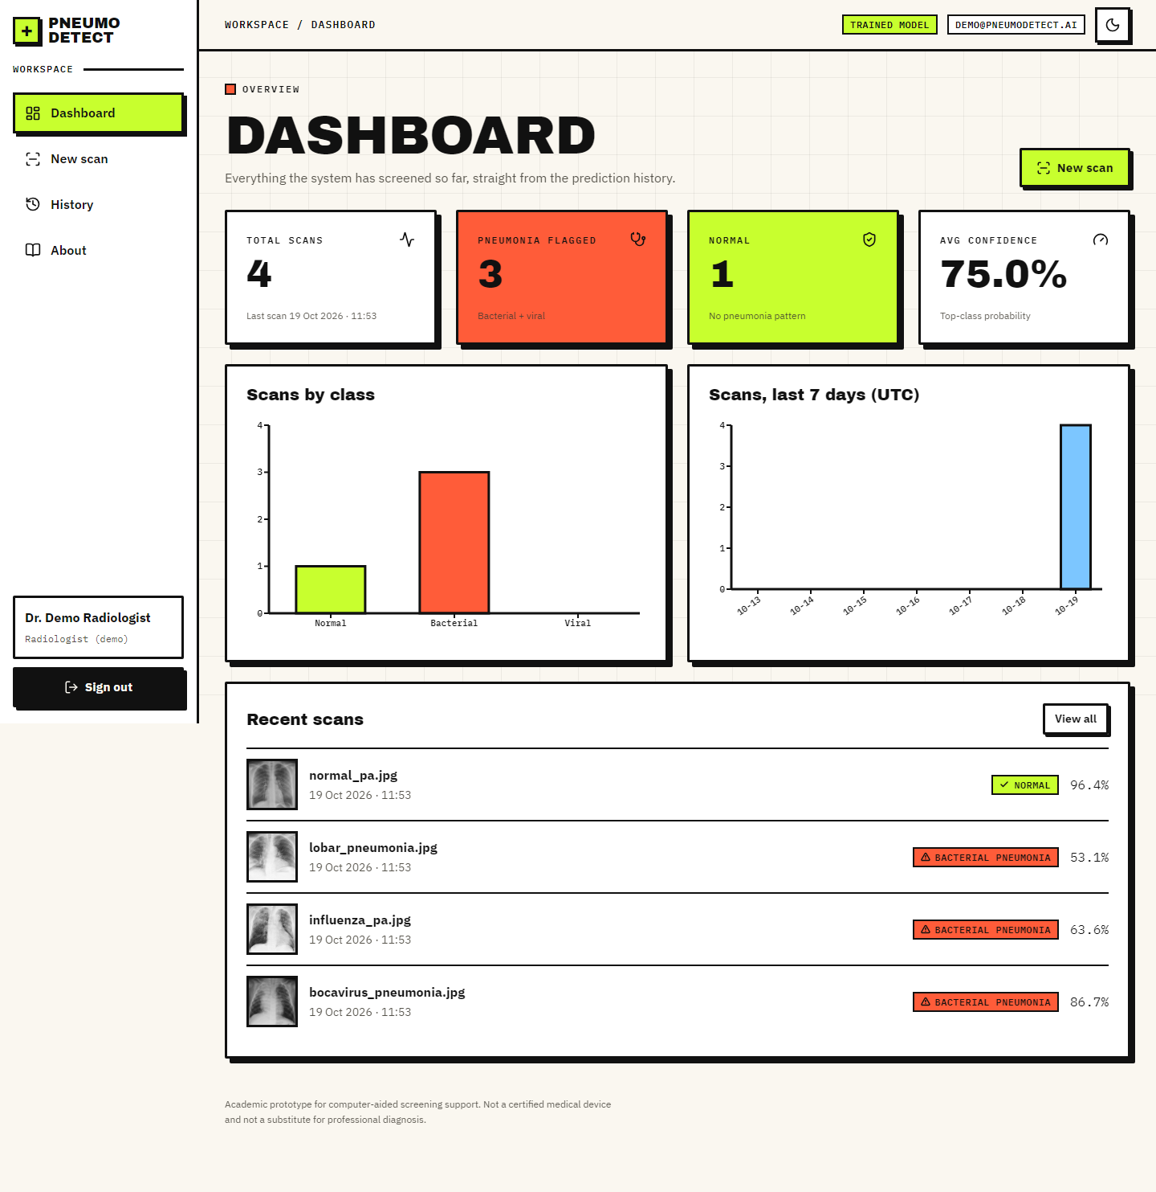
Figure 19: Dashboard: totals, class distribution, scans per day and the most recent scans
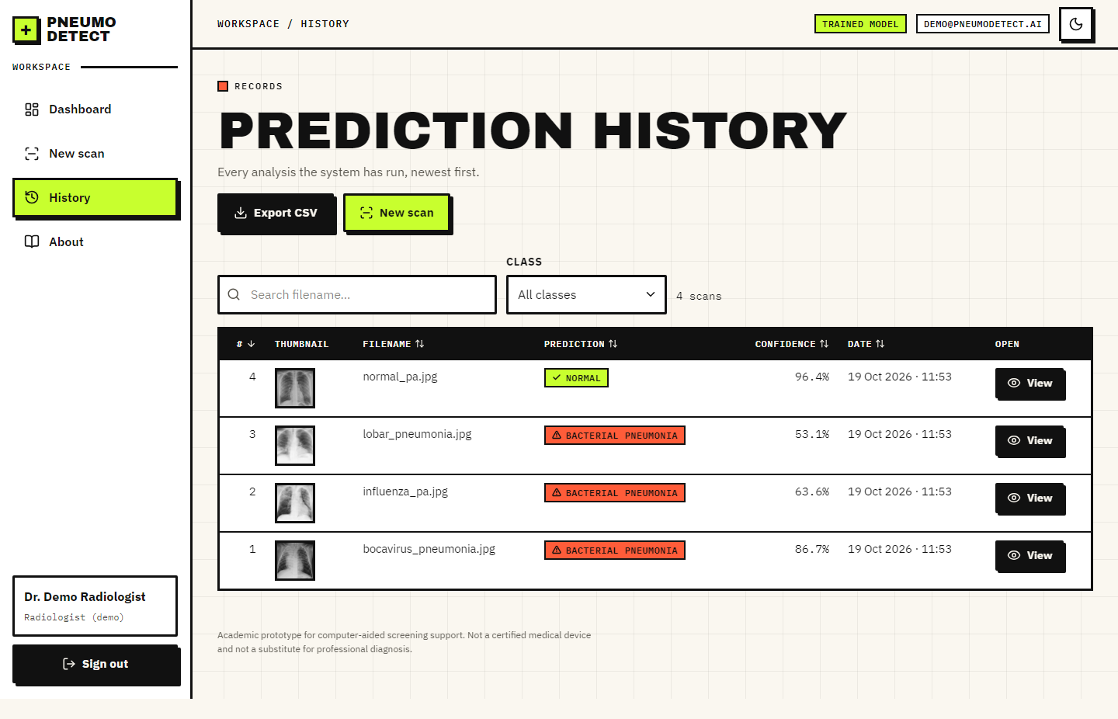
Figure 20: History: searchable, filterable, sortable table with thumbnails and CSV export
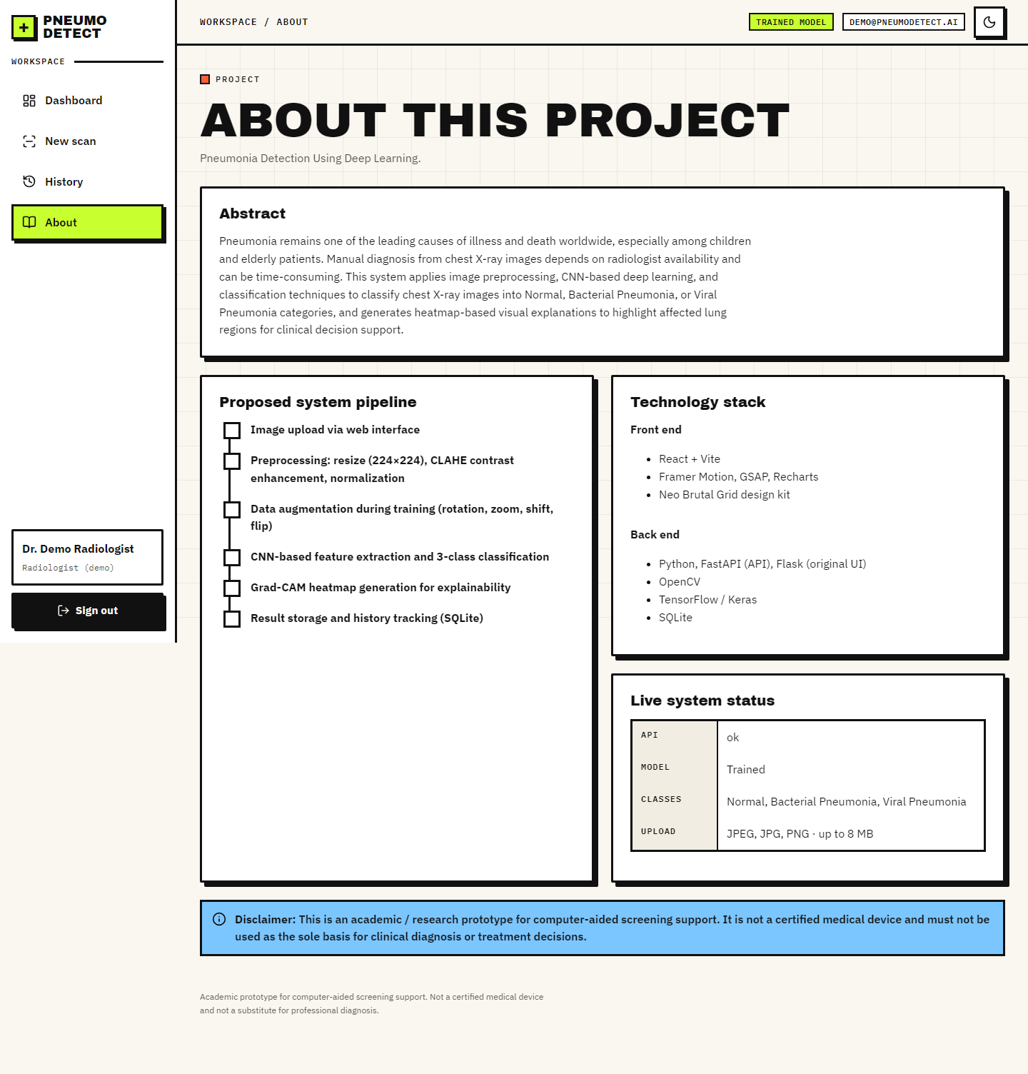
Figure 21: About screen: abstract, the five-step pipeline, technology and disclaimer

8.2 Experimental setup and protocol
All model results come from scripts/train_experiment.py, which writes experiments/<name>/metrics.json. The protocol of the main experiment is fixed before looking at any test result:
Table 24: Protocol of the main experiment
Item | Value
Data | Kermany et al. paediatric chest X-ray dataset, 5,856 images, three classes derived from file names
Training pool | Official train + val folders; patient-level 10 % validation split (stratified group split, seed 42)
Sizes | train 4,688 (2,635 patients) / validation 544 (293 patients) / test 624 (official, used once)
Model | custom CNN, 590,019 parameters, trained from scratch
Training | Adam 0.0003, batch 32, up to 40 epochs; 21 run, best epoch 11; about 214 s per epoch on a CPU
Class weights | Normal 1.29, Bacterial Pneumonia 0.69, Viral Pneumonia 1.28
Environment | TensorFlow 2.21.0, Python 3.11.9, Intel Core i5-12500, no GPU

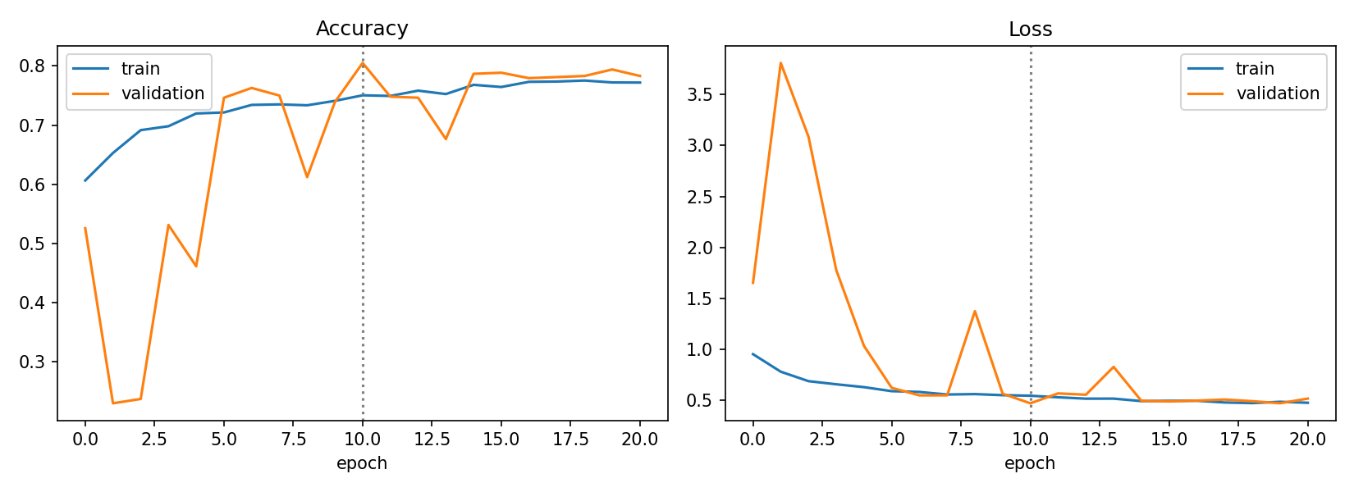
Figure 22: Training and validation accuracy and loss of the main experiment (dotted line: best epoch)
Validation accuracy of the restored best model is 80.5%. The validation curve is noisy, which is typical of batch-normalised networks trained from scratch on a small validation set (544 images).

8.3 Model performance on the official test split
Table 25: Per-class results on the official test split (n = 624)
Class | Precision | Recall | F1 | Support
Normal | 0.967 | 0.620 | 0.755 | 234
Bacterial Pneumonia | 0.835 | 0.959 | 0.892 | 242
Viral Pneumonia | 0.607 | 0.804 | 0.692 | 148
Macro average | 0.803 | 0.794 | 0.780 | 624

Overall three-class accuracy is 79.5% and the macro F1 is 0.780 (macro one-vs-rest AUC 0.933). The class recalled best is Bacterial Pneumonia (95.9%); the class recalled worst is Normal (62.0%).
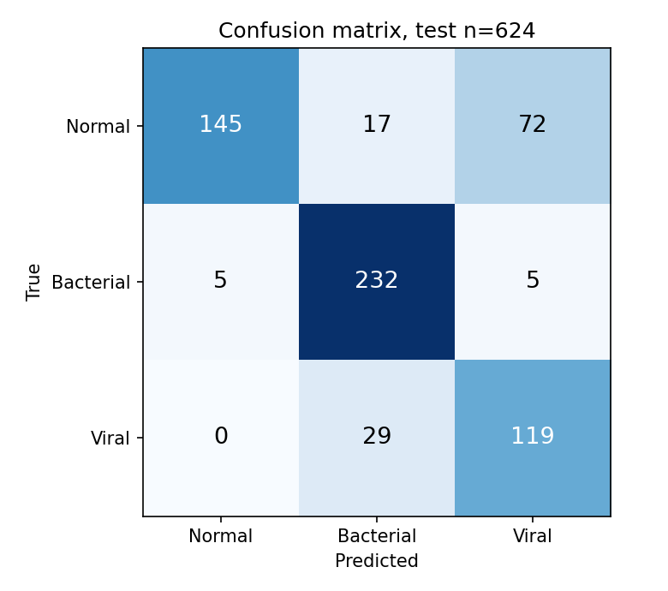
Figure 23: Confusion matrix on the official test split (rows: true class, columns: predicted class)
The largest single confusion is Normal images predicted as Viral (72 images), followed by Viral predicted as Bacterial (29 images).
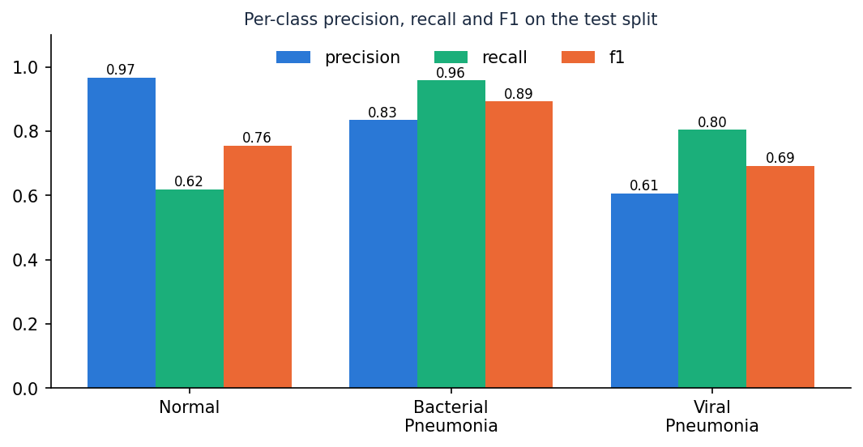
Figure 24: Per-class precision, recall and F1 on the official test split

Normal against pneumonia
Collapsing the two pneumonia classes gives the binary view used by most of the literature, with pneumonia as the positive class:
Table 26: Binary view of the same predictions
Measure | Value
True positives / false negatives | 385 / 5
True negatives / false positives | 145 / 89
Accuracy | 84.9%
Sensitivity (recall of pneumonia) | 98.7%
Specificity | 62.0%
Precision | 81.2%
F1 | 0.891
AUC (1 - P(Normal) as score) | 0.942

Calibration: the expected calibration error is 0.033 (10 bins) and the mean confidence is 0.777 against an accuracy of 0.795; a gap between the two means the softmax probability should not be read as a literal probability of being right.

8.4 Overlap between the training and test folders
Pneumonia file names carry a patient id (person123_virus_45.jpeg). Counting ids, 320 of the 624 official test images (320 of the 390 pneumonia images) have an id that also occurs in the training folders, while none of the 234 normal test images do. Shahi and Bagale [6] made the same observation about this dataset. Some of these coincidences may be different children given the same number, but the file names cannot show this, so the conservative reading is possible patient leakage.
The model's metrics on the 304 test images whose id does not occur in training are given next to the full-test metrics. The subset contains 234 normal, 48 bacterial and 22 viral images, so its class mix differs from the full test split.
Table 27: Full official test split against the id-disjoint subset
Measure | Full test (n = 624) | Id-disjoint subset (n = 304)
3-class accuracy | 79.5% | 69.7%
Pneumonia sensitivity | 98.7% | 98.6%
Normal specificity | 62.0% | 62.0%
Recall: Normal / Bacterial / Viral | 62.0% / 95.9% / 80.4% | 62.0% / 95.8% / 95.5%

A second, stricter protocol re-partitions all 5,856 images by patient (stratified group split, seed 42): 4,102 training, 899 validation and 855 test images with no id shared between the three parts (test images sharing an id with training: 0). The same network and settings reach 79.1% three-class accuracy and macro F1 0.779 on this test part, with pneumonia sensitivity 94.8% and normal specificity 94.0%. Its class mix and test size differ from the official split, so the two are reported side by side, not averaged.
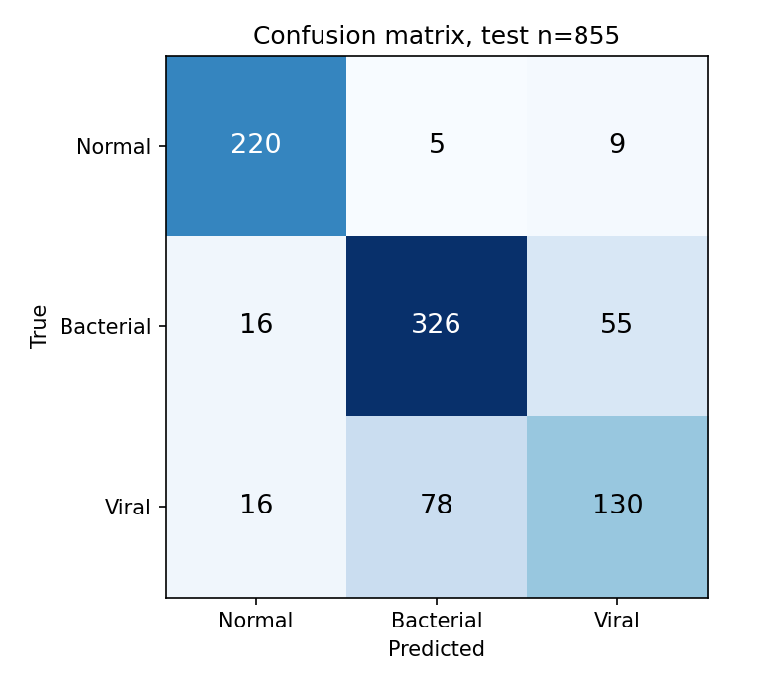
Figure 25: Confusion matrix of the patient-level re-partition

8.5 Ablation and comparison with MobileNetV3Small
Three further runs use the same code and seed. The CLAHE ablation removes the contrast step from training and inference; the MobileNetV3Small run uses the backbone that the base paper selects [1], [13], trained in two stages (head only, then fine-tuning) and evaluated on the same official test images. The patient-level run uses a different test part and is listed for completeness.
Table 28: Experiments compared
Experiment | Parameters | 3-class acc. | Macro F1 | Sensitivity | Specificity
Baseline: project defaults (lr 1e-4), stopped early | 590,019 | 68.1% | 0.655 | 99.0% | 35.5%
Tuned recipe (deployed model) | 590,019 | 79.5% | 0.780 | 98.7% | 62.0%
Tuned, no CLAHE (ablation) | 590,019 | 82.2% | 0.810 | 99.2% | 66.7%
MobileNetV3Small, ImageNet start (base-paper backbone) | 940,851 | 61.9% | 0.593 | 100.0% | 25.2%
Tuned, patient-level re-partition (own test part) | 590,019 | 79.1% | 0.779 | 94.8% | 94.0%

Removing CLAHE changes three-class accuracy by +2.7 percentage points and macro F1 by +0.030. With one seed per configuration this difference should be read as indicative; differences of a few points are within the run-to-run variation of small CNNs, which this project could not measure for lack of repeated runs. The variant without CLAHE scored higher on the test split, so this project does not show that the contrast step helps. Its validation accuracy (80.7%) was almost the same as that of the deployed model (80.5%), the deployed model had been chosen before the ablation was run, and the deployed application keeps CLAHE for consistency with the original project; re-training the deployed model without CLAHE is listed as future work.
The shipped gradcam.py cannot compute a heat map for the MobileNetV3Small model, because the backbone is a nested model and the feature tensor is not connected to the outer input; this is one reason the transfer-learning option was not deployed; its accuracy on these test images was also lower than that of the custom CNN.
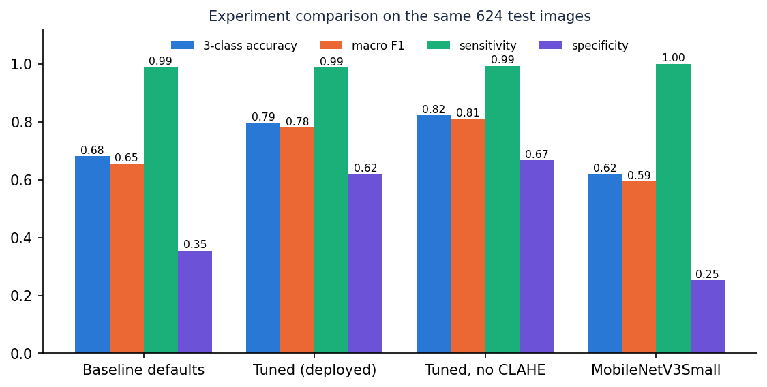
Figure 26: Comparison of the experiments on the official test images

8.6 Threshold analysis
Confidence threshold. A deployment could auto-report only scans whose top probability reaches a threshold and send the rest for review. The table below shows the trade-off on the test split: a higher threshold raises accuracy on the scans kept but reduces coverage.
Table 29: Accuracy against minimum confidence
Threshold | Scans kept | Coverage | Accuracy on kept
0.00 | 624 | 100.0% | 79.5%
0.50 | 585 | 93.8% | 82.1%
0.60 | 520 | 83.3% | 86.0%
0.70 | 446 | 71.5% | 89.5%
0.80 | 332 | 53.2% | 92.8%
0.90 | 148 | 23.7% | 95.3%
0.95 | 67 | 10.7% | 97.0%

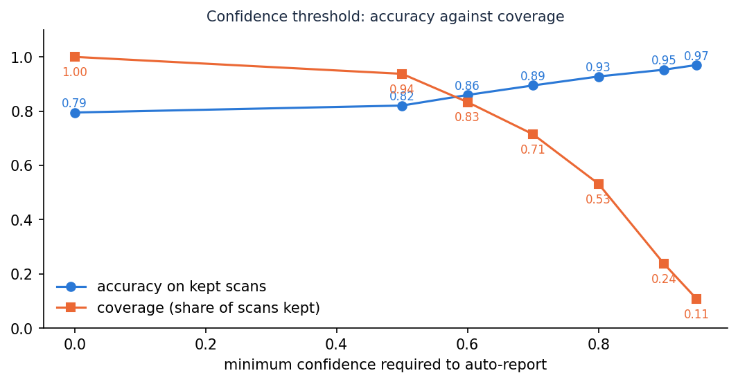
Figure 27: Accuracy on the scans kept and coverage as the minimum confidence rises
Decision threshold for pneumonia. Using the score 1 - P(Normal), sweeping the threshold moves the operating point between sensitivity and specificity. The default arg-max rule corresponds to a threshold near 0.5.
Table 30: Pneumonia decision-threshold sweep
Threshold | Sensitivity | Specificity | Accuracy
0.2 | 99.7% | 40.6% | 77.6%
0.3 | 99.7% | 47.9% | 80.3%
0.4 | 99.5% | 53.8% | 82.4%
0.5 | 99.2% | 58.1% | 83.8%
0.6 | 98.7% | 62.4% | 85.1%
0.7 | 97.4% | 67.1% | 86.1%
0.8 | 96.2% | 71.4% | 86.9%

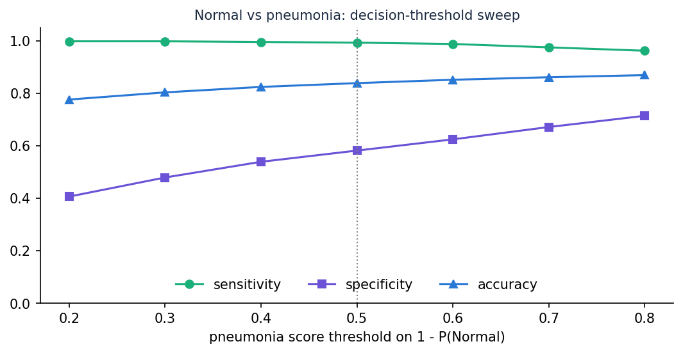
Figure 28: Sensitivity, specificity and accuracy against the pneumonia decision threshold

8.7 Comparison with the base paper
The datasets and protocols differ, so this table is context and not a ranking. The base paper's figures are taken from its text and abstract; those for this project are from Section 8.3.
Table 31: Base paper and this project
Aspect | Base paper [1] | This project
Task | Binary Normal / Pneumonia; 4-class COVID-19, Normal, Pneumonia, TB | 3-class Normal / Bacterial / Viral; binary view derived
Image source | Mendeley paediatric set (5,863 images) and a merged 7,135-image set | Same Kermany paediatric images (5,856 in the public folders)
Split | Balanced subset, 1,300 per class; 2,080 / 260 / 260 (binary) | Official imbalanced split; 4,688 / 544 / 624
Model | MobileNet family, ImageNet-pretrained; SSL with FixMatch, FlexMatch, FreeMatch | Custom CNN from scratch (590,019 parameters)
Reported accuracy | Up to 98 % (binary), 97 % (4-class); 97 % with 20 % / 30 % labels | 79.5% three-class; 84.9% Normal vs pneumonia
Explanation | Grad-CAM | Grad-CAM (on every scan, in the application)
Reliability | MC Dropout (50 passes, entropy 0.30), TTA, ECE | ECE 0.033; confidence-threshold analysis
Latency | 0.11 s per image (MobileNetV3Small) | 0.20 s per image for preprocessing, inference and Grad-CAM (CPU)
Deliverable | Research framework | Complete web application with history, dashboard and tests

Two points are worth stating plainly. First, the base paper's 97 to 98 % comes from a balanced 260-image test subset and from ImageNet-pretrained backbones; this project's 84.9% Normal-versus-pneumonia accuracy is on the official 624-image test split, which is about 62 % pneumonia, from a network trained from scratch, and three-class accuracy is a harder task. Second, studies on the same images report anywhere from 79.7 % to 98 % depending on the protocol [3], [5], [6], so a gap of several points between two papers is not evidence of a better method.

8.8 Sample inputs and outputs
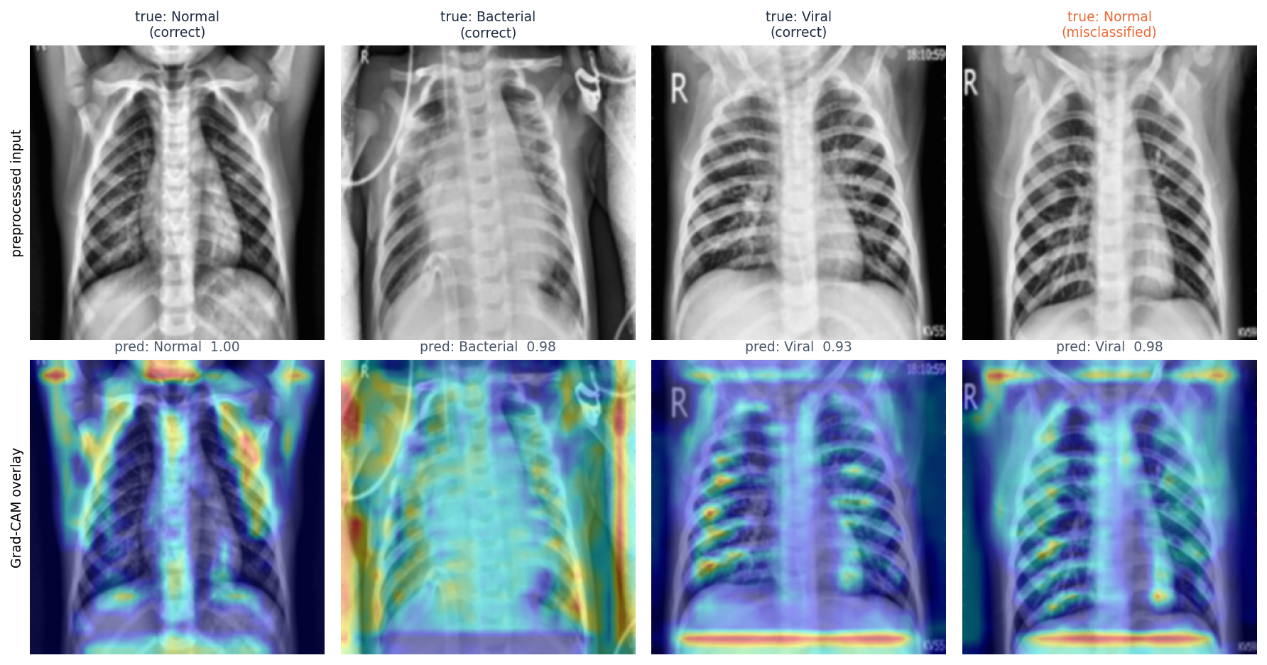
Figure 29: Grad-CAM overlays for the highest-confidence correct test image of each class and the most confident misclassification
The four public-domain sample radiographs in dataset_sample/ were sent through the running API. They come from Wikimedia Commons (not from the training data, and some are adult films), so they illustrate the interface and the output format, not accuracy. The class named in the source caption is shown for reference only; it is not a dataset label.
Table 32: Sample radiographs through the deployed API
File | Source caption | Predicted | Confidence | P(N / B / V) % | ms
normal_pa.jpg | Normal PA chest radiograph | Normal | 96.4% | 96 / 2 / 1 | 509
lobar_pneumonia.jpg | X-ray of lobar pneumonia | Bacterial Pneumonia | 53.1% | 0 / 53 / 47 | 351
influenza_pa.jpg | Chest radiograph in influenza | Bacterial Pneumonia | 63.6% | 0 / 64 / 36 | 657
bocavirus_pneumonia.jpg | Human bocavirus 1 pneumonia | Bacterial Pneumonia | 86.7% | 2 / 87 / 11 | 343

8.9 Success and failure analysis
Where it works. Pneumonia is detected as pneumonia in 98.7% of cases (5 of 390 pneumonia images were called normal) and bacterial pneumonia has a recall of 95.9%. The heat maps in the Grad-CAM figure are diffuse: in the correctly classified examples they cover parts of the lung fields but also the ribs, the shoulders, the corners and the diaphragm line, so they do not isolate a lesion.
Where it fails. The confusion counts above show the pattern:
• Normal predicted as Viral: 72 images
• Viral predicted as Bacterial: 29 images
• Normal predicted as Bacterial: 17 images
• Bacterial predicted as Viral: 5 images
In short, normal radiographs are the weak point: 72 of 234 are called viral and 17 bacterial pneumonia (specificity 62.0%), and viral precision is 0.61; confusion between the two pneumonia types is smaller (29 viral called bacterial, 5 bacterial called viral). A likely contributor, not tested here, is that the official test folder differs in distribution from the training folder; the patient-level re-partition (Section 8.4) removes most of this gap. Separating bacterial from viral pneumonia is hard in general because the two overlap on a radiograph and the pathogen label in this dataset comes from the file name, not from a re-read of the image. The most confident misclassification (last column of the Grad-CAM figure) shows that a wrong prediction can still carry a high confidence.
Why the heat maps need care. Grad-CAM shows where the network looked, not why a region matters clinically. Without segmentation the maps also highlight areas outside the lungs in some images (borders, text markers, the diaphragm line), which is a reason to treat the overlay as a prompt for inspection and not as a lesion detector.

8.10 Limitations of the results
• One data source, one seed per configuration: no confidence intervals and no repeated runs.
• Pathogen labels derive from file names and were not re-verified.
• Possible patient overlap between the official training and test folders; the id-disjoint and patient-level results are the safer reading.
• No external or prospective validation; the four sample images are illustrations.
• Probabilities are uncalibrated softmax values.

8.11 Objectives against outcomes
Table 33: Objectives of Section 1.5 and their outcome
Objective | Outcome | Evidence
1. Acquire and preprocess a dataset (resize, normalise, augment) | Achieved | Kermany data; preprocess.py; augmentation in train_experiment.py (Sections 6.2 and 6.3)
2. U-Net lung segmentation before classification | Not achieved | No segmentation network was implemented, trained or evaluated
3. Train a CNN to separate pneumonia from normal | Achieved | Three-class CNN; pneumonia sensitivity 98.7%, specificity 62.0%
4. Evaluate with accuracy, sensitivity, specificity, F1, confusion matrix | Achieved | Section 8.3, plus AUC, ECE and threshold analysis
5. Heat-map visualisation for each prediction | Achieved | Grad-CAM overlay on every scan (application and Section 8.8)
6. Deploy behind an interface with prediction, confidence and heat map | Achieved | FastAPI + React application, original Flask UI, 73 tests

CHAPTER 9: CONCLUSION

9.1 Summary
The project set out to build an explainable pneumonia detection system and to measure it honestly. It delivers a working pipeline in which a chest X-ray is validated, enhanced with CLAHE, classified by a compact CNN into Normal, Bacterial or Viral pneumonia, explained with a Grad-CAM heat map and stored with its result, behind a FastAPI service, a React interface and the original Flask interface. A reproducible training script, a patient-aware evaluation, ten design diagrams and an automated test suite complete the work.

9.2 Objectives achieved
Five of the six objectives were met: data preparation, a trained CNN classifier, the requested evaluation, heat-map visualisation and deployment behind an interface (Section 8.11). The second objective, U-Net lung segmentation, was not achieved: no segmentation network was implemented, so the classifier sees the whole radiograph.

9.3 Key findings
• A 590,019-parameter CNN trained on a desktop CPU reaches 79.5% three-class accuracy and macro F1 0.780 on the official 624-image test split.
• Viewed as pneumonia against normal, sensitivity is 98.7% and specificity 62.0%; normal radiographs are the weak point: 72 of 234 are called viral and 17 bacterial pneumonia (specificity 62.0%), and viral precision is 0.61; confusion between the two pneumonia types is smaller (29 viral called bacterial, 5 bacterial called viral).
• The official test folder shares pneumonia ids with the training folders; the id-disjoint and patient-level results in Chapter 8 should be preferred when judging generalisation.
• Reported accuracy on the same public images varies from about 80 % to 98 % across studies with different protocols, so numbers must be quoted with their protocol.
• The shipped Grad-CAM works only on flat networks; transfer-learning backbones need a Grad-CAM that reaches nested layers.
• The system is verified by 73 automated tests plus a live smoke test and browser checks.

9.4 Practical applications
• A teaching tool: students can upload a radiograph, see the probabilities and the heat map, and study where a CNN looks.
• A research scaffold: the training script, evaluation protocol and application can be reused with other chest X-ray datasets or models.
• A triage-support prototype: with proper validation, confidence thresholds could flag low-confidence scans for review.

9.5 Known limitations
• No U-Net segmentation. One of the six stated objectives was not met; the model may use image regions outside the lungs, and the Grad-CAM maps in Chapter 8 show that it sometimes does.
• Single data source. All training and test images come from one paediatric centre. The official test split is known to differ in distribution from the training split, and no external hospital data were available, so the reported figures say little about performance elsewhere.
• Modest absolute accuracy. Normal radiographs are often called pneumonia and the two pneumonia types overlap on a radiograph alone; the confusion matrix in Chapter 8 shows where the model fails.
• CPU-only training. All training was run on a desktop CPU (no GPU), which limited the number of experiments and made large backbones impractical.
• Class labels from file names. Pathogen type is not independently verified by the authors of this project.
• Uncalibrated probabilities. Confidence is the raw softmax output; no temperature scaling or Monte Carlo Dropout is applied, so a high confidence is not a guarantee of correctness.

CHAPTER 10: FUTURE SCOPE

10.1 Improvements to the model
• U-Net lung segmentation (objective 2): train a segmentation network [10] on lung masks and classify only the lung region, which should also make Grad-CAM maps more specific.
• Transfer learning with a Grad-CAM that reaches nested backbones (for example by building a flat model from the backbone's layers), so that MobileNetV3Small, EfficientNet or DenseNet can be deployed with explanations.
• Calibrated uncertainty: temperature scaling and Monte Carlo Dropout [15] so that confidence tracks accuracy, and an automatic 'send for review' flag.
• Orientation-safe augmentation: remove horizontal flips, as the base paper does, and measure the effect.
• Repeated runs and cross-validation at patient level to give confidence intervals.

10.2 Additional features
• Real user accounts and roles, an audit log of who analysed which scan, and per-user histories.
• DICOM input and metadata handling; batch upload; PDF report generation.
• A reviewer workflow in which a clinician confirms or corrects a prediction, feeding a labelled set for retraining.
• Multi-language interface and printable reports for the target clinics.

10.3 Scalability and deployment
• Package the API and the built front end in containers behind a reverse proxy with HTTPS; replace SQLite by a server database and the local folders by object storage.
• Serve the model from a dedicated inference process or a GPU host with a queue, instead of the in-process lock.
• Add monitoring of latency, error rates and the distribution of predicted classes to detect drift.

10.4 Further research
• External validation on adult and multi-hospital data and a prospective clinical study.
• Semi-supervised learning with FixMatch, FlexMatch or FreeMatch [1], [14] to use unlabelled radiographs.
• A study of how clinicians use the heat map, and whether it improves or biases their decisions.
• Joint modelling of segmentation, classification and uncertainty in one network.

REFERENCES
[1] S. M. Mahin, T. Hasan, S. Karim, M. B. R. Nuha, E. H. Tusher, A. R. Hussain, J. Uddin, and D. Ghose, "From pneumonia to multi-disease: Interpretable and uncertainty-aware semi-supervised learning strategies for chest X-ray classification," IEEE Access, vol. 14, pp. 127532-127551, 2026, doi: 10.1109/ACCESS.2026.3722370.
[2] World Health Organization, "Pneumonia," fact sheet, 2024. [Online]. Available: https://www.who.int/news-room/fact-sheets/detail/pneumonia
[3] D. S. Kermany et al., "Identifying medical diagnoses and treatable diseases by image-based deep learning," Cell, vol. 172, no. 5, pp. 1122-1131, Feb. 2018.
[4] D. Kermany, K. Zhang, and M. Goldbaum, "Labeled optical coherence tomography (OCT) and chest X-ray images for classification," Mendeley Data, v3, 2018, doi: 10.17632/rscbjbr9sj.3.
[5] A. O. Khadidos, A. Nanyonga, A. O. Khadidos, O. M. Mirza, and M. T. Yilmaz, "Explainable deep learning for pediatric pneumonia detection in chest X-ray images," arXiv:2601.09814, Jan. 2026.
[6] K. Shahi and A. Bagale, "Weakly supervised pneumonia localization from chest X-rays using deep neural network and Grad-CAM explanations," arXiv:2511.00456, 2025.
[7] P. Rajpurkar et al., "CheXNet: Radiologist-level pneumonia detection on chest X-rays with deep learning," arXiv:1711.05225, 2017.
[8] X. Wang, Y. Peng, L. Lu, Z. Lu, M. Bagheri, and R. M. Summers, "ChestX-ray8: Hospital-scale chest X-ray database and benchmarks on weakly-supervised classification and localization of common thorax diseases," in Proc. IEEE Conf. Comput. Vis. Pattern Recognit. (CVPR), Jul. 2017, pp. 3462-3471.
[9] R. R. Selvaraju, M. Cogswell, A. Das, R. Vedantam, D. Parikh, and D. Batra, "Grad-CAM: Visual explanations from deep networks via gradient-based localization," Int. J. Comput. Vis., vol. 128, no. 2, pp. 336-359, Feb. 2020.
[10] O. Ronneberger, P. Fischer, and T. Brox, "U-Net: Convolutional networks for biomedical image segmentation," in Proc. Med. Image Comput. Comput.-Assist. Intervent. (MICCAI), 2015, pp. 234-241.
[11] K. Zuiderveld, "Contrast limited adaptive histogram equalization," in Graphics Gems IV, P. S. Heckbert, Ed. San Diego, CA, USA: Academic Press, 1994, pp. 474-485.
[12] A. G. Howard et al., "MobileNets: Efficient convolutional neural networks for mobile vision applications," arXiv:1704.04861, 2017.
[13] A. Howard et al., "Searching for MobileNetV3," in Proc. IEEE/CVF Int. Conf. Comput. Vis. (ICCV), Sep. 2019, pp. 1314-1324.
[14] K. Sohn et al., "FixMatch: Simplifying semi-supervised learning with consistency and confidence," in Proc. Adv. Neural Inf. Process. Syst., vol. 33, 2020, pp. 596-608.
[15] Y. Gal and Z. Ghahramani, "Dropout as a Bayesian approximation: Representing model uncertainty in deep learning," in Proc. Int. Conf. Mach. Learn. (ICML), 2016, pp. 1050-1059.
[16] D. P. Kingma and J. Ba, "Adam: A method for stochastic optimization," arXiv:1412.6980, 2014.
[17] S. Ioffe and C. Szegedy, "Batch normalization: Accelerating deep network training by reducing internal covariate shift," in Proc. Int. Conf. Mach. Learn. (ICML), 2015, pp. 448-456.
[18] N. Srivastava, G. Hinton, A. Krizhevsky, I. Sutskever, and R. Salakhutdinov, "Dropout: A simple way to prevent neural networks from overfitting," J. Mach. Learn. Res., vol. 15, pp. 1929-1958, 2014.
[19] M. Abadi et al., "TensorFlow: A system for large-scale machine learning," in Proc. 12th USENIX Symp. Oper. Syst. Design Implement. (OSDI), 2016, pp. 265-283.
[20] T. Ozturk, M. Talo, E. A. Yildirim, U. B. Baloglu, O. Yildirim, and U. R. Acharya, "Automated detection of COVID-19 cases using deep neural networks with X-ray images," Comput. Biol. Med., vol. 121, Art. no. 103792, Jun. 2020.
[21] L. Wang, Z. Q. Lin, and A. Wong, "COVID-Net: A tailored deep convolutional neural network design for detection of COVID-19 cases from chest X-ray images," Sci. Rep., vol. 10, no. 1, Art. no. 19549, Nov. 2020.
[22] F. Alshanketi et al., "Pneumonia detection from chest X-ray images using deep learning and transfer learning for imbalanced datasets," J. Imaging Inform. Med., vol. 38, no. 4, pp. 2021-2040, Nov. 2024.
[23] H. Malik, T. Anees, M. Din, and A. Naeem, "CDC_Net: Multi-classification convolutional neural network model for detection of COVID-19, pneumothorax, pneumonia, lung cancer, and tuberculosis using chest X-rays," Multimedia Tools Appl., vol. 82, no. 9, pp. 13855-13880, Apr. 2023.
[24] R. Kumar, C.-T. Pan, Y.-M. Lin, S. Yow-Ling, T.-S. Chung, and U. G. S. Janesha, "Enhanced multi-model deep learning for rapid and precise diagnosis of pulmonary diseases using chest X-ray imaging," Diagnostics, vol. 15, no. 3, p. 248, 2025.
[25] R. Siddiqi and S. Javaid, "Deep learning for pneumonia detection in chest X-ray images: A comprehensive survey," J. Imaging, vol. 10, no. 8, p. 176, Jul. 2024.
[26] M. F. Hashmi, A. A. Husain, D. M. Kotambkar, and K. D. Kumar, "Hybrid deep learning and handcrafted feature fusion for pneumonia detection in chest X-rays," J. Electr. Syst. Inf. Technol., vol. 12, no. 1, p. 94, Nov. 2025.
[27] R. Vyas and D. R. Khadatkar, "Ensemble of deep learning architectures with machine learning for pneumonia classification using chest X-rays," J. Imaging Inform. Med., vol. 38, no. 2, pp. 727-746, Aug. 2024.
[28] G. Litjens et al., "A survey on deep learning in medical image analysis," Med. Image Anal., vol. 42, pp. 60-88, 2017.
[29] C. Guo, G. Pleiss, Y. Sun, and K. Q. Weinberger, "On calibration of modern neural networks," in Proc. Int. Conf. Mach. Learn. (ICML), 2017, pp. 1321-1330.
[30] "Pneumonia detection from chest X-ray images using convolutional neural networks," 2025 (entry recorded in the batch literature survey).
[31] "PseudoColorViT-CXR: Colormap-enhanced vision transformers for tuberculosis and pneumonia detection from grayscale chest X-ray images," 2025 (entry recorded in the batch literature survey).
[32] "Pneumonia detection using chest X-ray," Int. Sci. J. Eng. Manag., 2025 (entry recorded in the batch literature survey).
[33] "Reproducibility and external threshold-transfer audit of transfer-learning CNNs for pediatric chest X-ray pneumonia detection," 2026 (entry recorded in the batch literature survey).
[34] S. Ramirez, "FastAPI framework, high performance, easy to learn, fast to code, ready for production." [Online]. Available: https://fastapi.tiangolo.com
[35] G. Bradski, "The OpenCV library," Dr. Dobb's Journal of Software Tools, 2000.
[36] A. Ronacher and Pallets Projects, "Flask web development, one drop at a time." [Online]. Available: https://flask.palletsprojects.com
[37] A. Chattopadhay, A. Sarkar, P. Howlader, and V. N. Balasubramanian, "Grad-CAM++: Generalized gradient-based visual explanations for deep convolutional networks," in Proc. IEEE Winter Conf. Appl. Comput. Vis. (WACV), Mar. 2018, pp. 839-847.

APPENDIX A: IMPORTANT CODE
The listings below are extracted from the repository by the document build script, so they are the code that was tested and measured. File paths are relative to 8.ProjectCode.

A.1 Preprocessing (`model/preprocess.py`)
def apply_clahe(gray_image: np.ndarray) -> np.ndarray:
"""Apply CLAHE to a single-channel (grayscale) image."""
clahe = cv2.createCLAHE(clipLimit=2.5, tileGridSize=(8, 8))
return clahe.apply(gray_image)

def load_and_preprocess_image(path_or_bytes, apply_enhancement: bool = True) -> np.ndarray:
"""
Load an image from a file path (or raw bytes buffer), preprocess it,
and return a float32 array of shape (224, 224, 3) normalized to [0, 1].
"""
if isinstance(path_or_bytes, (bytes, bytearray)):
arr = np.frombuffer(path_or_bytes, dtype=np.uint8)
img = cv2.imdecode(arr, cv2.IMREAD_GRAYSCALE)
else:
img = cv2.imread(str(path_or_bytes), cv2.IMREAD_GRAYSCALE)

if img is None:
raise ValueError(f"Could not read image: {path_or_bytes}")

# Resize to model input size
img = cv2.resize(img, IMG_SIZE, interpolation=cv2.INTER_AREA)

# Contrast Limited Adaptive Histogram Equalization
if apply_enhancement:
img = apply_clahe(img)

# Mild denoising (helps with scanner/JPEG artefact noise)
img = cv2.GaussianBlur(img, (3, 3), 0)

# Grayscale -> 3-channel so it can feed either a custom CNN or a
# transfer-learning backbone (DenseNet/ResNet/EfficientNet all expect 3ch)
img_rgb = cv2.cvtColor(img, cv2.COLOR_GRAY2RGB)

# Normalize to [0, 1]
img_norm = img_rgb.astype("float32") / 255.0

return img_norm

A.2 Network definition (`model/model_builder.py`)
def build_custom_cnn(input_shape=INPUT_SHAPE, num_classes=3, learning_rate=1e-4):
"""A from-scratch CNN classifier. No pretrained weights required."""
inputs = Input(shape=input_shape)

x = layers.Conv2D(32, 3, padding="same", activation="relu")(inputs)
x = layers.BatchNormalization()(x)
x = layers.MaxPooling2D()(x)

x = layers.Conv2D(64, 3, padding="same", activation="relu")(x)
x = layers.BatchNormalization()(x)
x = layers.MaxPooling2D()(x)

x = layers.Conv2D(128, 3, padding="same", activation="relu")(x)
x = layers.BatchNormalization()(x)
x = layers.MaxPooling2D()(x)

x = layers.Conv2D(256, 3, padding="same", activation="relu", name="last_conv")(x)
x = layers.BatchNormalization()(x)
x = layers.MaxPooling2D()(x)

x = layers.GlobalAveragePooling2D()(x)
x = layers.Dense(512, activation="relu")(x)
x = layers.BatchNormalization()(x)
x = layers.Dropout(0.35)(x)
x = layers.Dense(128, activation="relu")(x)
x = layers.Dropout(0.25)(x)
outputs = layers.Dense(num_classes, activation="softmax")(x)

model = models.Model(inputs, outputs, name="pneumonia_custom_cnn")
model.compile(
optimizer=Adam(learning_rate=learning_rate),
loss="categorical_crossentropy",
metrics=["accuracy", "AUC", "Precision", "Recall"],
)
return model

def find_last_conv_layer(model):
"""
Utility used by Grad-CAM to locate the last actual convolutional layer
(not a pooling/batchnorm layer that merely has a 4D output) so the
heatmap reflects genuine learned spatial features.
"""
conv_layer = None
fallback_4d = None
for layer in model.layers:
try:
shape = layer.output.shape
except AttributeError:
continue
if shape is not None and len(shape) == 4:
fallback_4d = layer.name
if "conv" in layer.__class__.__name__.lower():
conv_layer = layer.name
if conv_layer is not None:
return conv_layer
if fallback_4d is not None:
return fallback_4d
raise ValueError("No 4D (conv) layer found in model for Grad-CAM.")

A.3 Grad-CAM (`model/gradcam.py`)
def make_gradcam_heatmap(img_array, model, last_conv_layer_name, pred_index=None):
"""
img_array: shape (1, H, W, 3), already preprocessed/normalized.
Returns a 2D heatmap (values in [0, 1]) the same spatial size as the
last convolutional feature map.
"""
grad_model = tf.keras.models.Model(
model.inputs, [model.get_layer(last_conv_layer_name).output, model.output]
)

with tf.GradientTape() as tape:
conv_outputs, predictions = grad_model(img_array)
if pred_index is None:
pred_index = tf.argmax(predictions[0])
class_channel = predictions[:, pred_index]

grads = tape.gradient(class_channel, conv_outputs)
pooled_grads = tf.reduce_mean(grads, axis=(0, 1, 2))

conv_outputs = conv_outputs[0]
heatmap = conv_outputs @ pooled_grads[..., tf.newaxis]
heatmap = tf.squeeze(heatmap)

heatmap = tf.maximum(heatmap, 0) / (tf.math.reduce_max(heatmap) + 1e-8)
return heatmap.numpy(), int(pred_index)

def overlay_heatmap(original_rgb_uint8, heatmap, alpha=0.4):
"""
Overlay a Grad-CAM heatmap on top of the original (224,224,3) uint8
RGB image. Returns a uint8 RGB image ready to save/display.
"""
heatmap_resized = cv2.resize(heatmap, (original_rgb_uint8.shape[1], original_rgb_uint8.shape[0]))
heatmap_uint8 = np.uint8(255 * heatmap_resized)
heatmap_color = cv2.applyColorMap(heatmap_uint8, cv2.COLORMAP_JET)
heatmap_color = cv2.cvtColor(heatmap_color, cv2.COLOR_BGR2RGB)

overlaid = cv2.addWeighted(original_rgb_uint8, 1 - alpha, heatmap_color, alpha, 0)
return overlaid

A.4 Database layer (`database/db.py`)
def init_db():
conn = get_connection()
conn.execute(
"""
CREATE TABLE IF NOT EXISTS predictions (
id INTEGER PRIMARY KEY AUTOINCREMENT,
filename TEXT NOT NULL,
original_path TEXT NOT NULL,
heatmap_path TEXT NOT NULL,
prediction TEXT NOT NULL,
confidence REAL NOT NULL,
prob_normal REAL,
prob_bacterial REAL,
prob_viral REAL,
created_at TEXT NOT NULL
)
"""
)
conn.commit()
conn.close()

def insert_prediction(filename, original_path, heatmap_path, prediction,
confidence, prob_normal, prob_bacterial, prob_viral):
conn = get_connection()
cur = conn.execute(
"""
INSERT INTO predictions
(filename, original_path, heatmap_path, prediction, confidence,
prob_normal, prob_bacterial, prob_viral, created_at)
VALUES (?, ?, ?, ?, ?, ?, ?, ?, ?)
""",
(filename, original_path, heatmap_path, prediction, confidence,
prob_normal, prob_bacterial, prob_viral, datetime.utcnow().isoformat()),
)
conn.commit()
new_id = cur.lastrowid
conn.close()
return new_id

A.5 Session tokens and login (`backend/main.py`)
def _sign(payload: str) -> str:
return hmac.new(SESSION_SECRET, payload.encode(), hashlib.sha256).hexdigest()

def make_token(email: str) -> str:
body = base64.urlsafe_b64encode(json.dumps({"e": email, "x": int(time.time()) + SESSION_TTL}).encode()).decode()
return f"{body}.{_sign(body)}"

def read_token(token):
if not token or "." not in token:
return None
body, sig = token.rsplit(".", 1)
if not hmac.compare_digest(sig, _sign(body)):
return None
try:
data = json.loads(base64.urlsafe_b64decode(body.encode()))
except Exception:
return None
return data if data.get("x", 0) > time.time() else None

def current_user(request: Request):
data = read_token(request.cookies.get(COOKIE))
if not data:
raise HTTPException(401, "Please sign in to continue.")
return {"email": data["e"], "name": DEMO_NAME, "role": DEMO_ROLE}

@api.post("/api/auth/login")
def login(body: Login, response: Response):
ok = hmac.compare_digest(body.email.strip().lower(), DEMO_EMAIL.lower()) and hmac.compare_digest(
body.password, DEMO_PASSWORD
)
if not ok:
raise HTTPException(401, "Wrong email or password.")
response.set_cookie(COOKIE, make_token(DEMO_EMAIL), max_age=SESSION_TTL, httponly=True, samesite="lax")
return {"email": DEMO_EMAIL, "name": DEMO_NAME, "role": DEMO_ROLE}

A.6 Prediction route (`backend/main.py`)
@api.post("/api/predict", status_code=201)
def predict(xray_image: UploadFile = File(None), user=Depends(current_user)):
# same validation order as the Flask /predict route
if xray_image is None:
bad(400, "No file part in the request.")
if not xray_image.filename:
bad(400, "Please choose an X-ray image to upload.")
if not flask_app.allowed_file(xray_image.filename):
bad(400, "Unsupported file type. Please upload a JPG or PNG image.")
data = xray_image.file.read(MAX_BYTES + 1)
if len(data) > MAX_BYTES:
bad(413, f"File is too large. The limit is {MAX_BYTES // (1024 * 1024)} MB.")

model = flask_app.get_model()
ext = xray_image.filename.rsplit(".", 1)[1].lower()
unique_id = uuid.uuid4().hex[:12]
saved_name = f"{unique_id}.{ext}"
saved_path = os.path.join(flask_app.UPLOAD_FOLDER, saved_name)
with open(saved_path, "wb") as f:
f.write(data)

try:
preprocessed = load_and_preprocess_image(saved_path)
display_img = preprocess_for_display(saved_path)
except ValueError:
os.remove(saved_path)
bad(400, "That file could not be read as an image. Try another X-ray.")
batch = np.expand_dims(preprocessed, axis=0)

with _predict_lock:
probs = model.predict(batch, verbose=0)[0]
pred_idx = int(np.argmax(probs))
heatmap, _ = make_gradcam_heatmap(batch, model, flask_app._last_conv_layer, pred_index=pred_idx)

names = flask_app._class_names
prob_map = {n: float(p) for n, p in zip(names, probs)}
overlay = overlay_heatmap(display_img, heatmap, alpha=0.4)
heatmap_name = f"{unique_id}_heatmap.png"
cv2.imwrite(os.path.join(flask_app.HEATMAP_FOLDER, heatmap_name), cv2.cvtColor(overlay, cv2.COLOR_RGB2BGR))

pred_id = db.insert_prediction(
filename=xray_image.filename,
original_path=f"uploads/{saved_name}",
heatmap_path=f"heatmaps/{heatmap_name}",
prediction=names[pred_idx],
confidence=float(probs[pred_idx]),
prob_normal=prob_map.get("Normal", 0.0),
prob_bacterial=prob_map.get("Bacterial Pneumonia", 0.0),
prob_viral=prob_map.get("Viral Pneumonia", 0.0),
)
return serialize(db.get_prediction(pred_id))

A.7 Training and evaluation (`scripts/train_experiment.py`)
The data split, the augmentation generator, class weights and the fit call:
if args.protocol == "official":
sgkf = StratifiedGroupKFold(n_splits=10, shuffle=True, random_state=SEED)
tr_idx, va_idx = next(sgkf.split(pool, y_pool, groups))
assert not set(groups[tr_idx]) & set(groups[va_idx]), "patient leakage between train and validation"
X_tr, y_tr, g_tr = X_pool[tr_idx], y_pool[tr_idx], groups[tr_idx]
X_va, y_va, g_va = X_pool[va_idx], y_pool[va_idx], groups[va_idx]
else: # patient-disjoint re-partition of all 5,856 images
all_paths = pool + test_paths
X_all = np.concatenate([X_pool, X_test])
y_all = np.concatenate([y_pool, y_test])
g_all = np.concatenate([groups, groups_test])
outer = StratifiedGroupKFold(n_splits=7, shuffle=True, random_state=SEED)
rest_idx, te_idx = next(outer.split(all_paths, y_all, g_all))
inner = StratifiedGroupKFold(n_splits=6, shuffle=True, random_state=SEED)
tr_rel, va_rel = next(inner.split(rest_idx, y_all[rest_idx], g_all[rest_idx]))
tr_idx, va_idx = rest_idx[tr_rel], rest_idx[va_rel]
assert not (set(g_all[tr_idx]) & set(g_all[va_idx])) and not (set(g_all[tr_idx]) & set(g_all[te_idx])) and not (set(g_all[va_idx]) & set(g_all[te_idx])), "patient leakage between splits"
X_tr, y_tr, g_tr = X_all[tr_idx], y_all[tr_idx], g_all[tr_idx]
X_va, y_va, g_va = X_all[va_idx], y_all[va_idx], g_all[va_idx]
X_test, y_test = X_all[te_idx], y_all[te_idx]
test_paths = [all_paths[i] for i in te_idx]
groups_test = g_all[te_idx]

if args.smoke:
keep = np.random.RandomState(SEED).permutation(len(y_tr))[:200]
X_tr, y_tr, g_tr = X_tr[keep], y_tr[keep], g_tr[keep]
args.epochs, args.head_epochs = 1, 1

aug = ImageDataGenerator(
rotation_range=12, width_shift_range=0.08, height_shift_range=0.08,
shear_range=0.08, zoom_range=0.12, horizontal_flip=True, fill_mode="nearest",
) # same ranges as model.preprocess.get_train_augmentor, minus the rescale (images are already in [0,1])

def train_batches():
gen = aug.flow((X_tr.astype("float32")[..., None] / 255.0), tf.keras.utils.to_categorical(y_tr, 3),
batch_size=args.batch_size, shuffle=True, seed=SEED)
for xb, yb in gen:
yield np.repeat(xb, 3, axis=-1), yb

steps = int(np.ceil(len(X_tr) / args.batch_size))
train_ds = tf.data.Dataset.from_generator(
train_batches,
output_signature=(tf.TensorSpec((None, 224, 224, 3), tf.float32), tf.TensorSpec((None, 3), tf.float32)),
).repeat().prefetch(2) # the augmentation generator runs while the previous batch trains

Xv = to_input(X_va)
yv = tf.keras.utils.to_categorical(y_va, 3)

APPENDIX B: INSTALLATION AND USER GUIDE

B.1 Requirements
• Windows 10 or 11, Python 3.10 or 3.11 on PATH, Node.js 18 or newer on PATH.
• About 2 GB of disk space for the Python environment (TensorFlow) and a modern browser.

B.2 One-click start
1. Open the folder 8.ProjectCode and double-click run.bat, or run it from a terminal in that folder.
2. On the first run it creates .venv, installs requirements.txt and requirements-api.txt (several minutes), and runs npm install in frontend/.
3. Two console windows open, PneumoDetect API (port 8312) and PneumoDetect UI (port 5312), and the browser opens http://localhost:5312.
4. Wait about twenty seconds on the very first request while TensorFlow loads the model.
5. Stop everything with stop.bat or by closing the two windows.
The ports and the demo credentials are set in .env (copy .env.example if it is missing). run.bat flask starts the original Flask interface on port 5000 instead.

B.3 Manual start
# terminal 1, project root
.venv\Scripts\python -m uvicorn backend.main:api --port 8312

# terminal 2
cd frontend
npm install
npm run dev

B.4 Using the application
Table 34: Walk-through
Step | Action | Result
1 | Open http://localhost:5312 and choose Sign in; press Fill demo credentials and Sign in (demo@pneumodetect.ai / Pneumo@123) | The dashboard opens
2 | Open New scan; drop a PNG or JPG chest X-ray (up to 8 MB) or choose a file | A preview and the file details appear
3 | Press Analyse | A progress bar runs; the result page opens
4 | Read the class badge, confidence and probability bars; switch between Side by side and Blend heatmap | The Grad-CAM overlay shows the regions that drove the prediction
5 | Use Print report, Download heatmap or Delete scan as needed | A report, an image file, or a confirmation dialog
6 | Open History; search by file name, filter by class, sort a column, or Export CSV | The table updates; a CSV file downloads
7 | Open Dashboard for totals, class distribution and scans per day | Charts and recent scans

B.5 Training a model
python scripts/train_experiment.py --data_root <path to chest_xray> --name exp01_custom_cnn_clahe \
--export_model saved_models
# restart the API: the Demo Mode badge changes to 'Trained model'

The data folder must contain train/, val/ and test/ with NORMAL/ and PNEUMONIA/ sub-folders (the public "chest_xray" layout). scripts/leakage_analysis.py and scripts/make_figures.py then recompute the analysis and the figures used in this report.

B.6 Running the tests
python -m pytest tests -q # 73 tests, about one minute
python scripts/smoke_test.py # with the servers running
python scripts/verify_ui.py # needs: pip install playwright; playwright install chromium
python scripts/capture_screens.py # regenerates docs/screenshots

B.7 Troubleshooting
• "The API is not reachable": the API window is not running or is still loading TensorFlow. Check the PneumoDetect API window.
• Port already in use: change BACKEND_PORT or FRONTEND_PORT in .env and start again.
• `ModuleNotFoundError: cv2` outside run.bat: pip install -r requirements.txt -r requirements-api.txt into the Python you are using.
• TensorFlow fails to start with a DLL error after other scientific libraries were imported first: import TensorFlow first (the project scripts do).

APPENDIX C: ADDITIONAL SCREENS
All screenshots are captures of the running application at 1440 x 900 with real scans in the history. The two Demo Mode screens (the last two figures) were taken before the model was trained and are kept to document that state.
Figure 30: Landing page, light theme
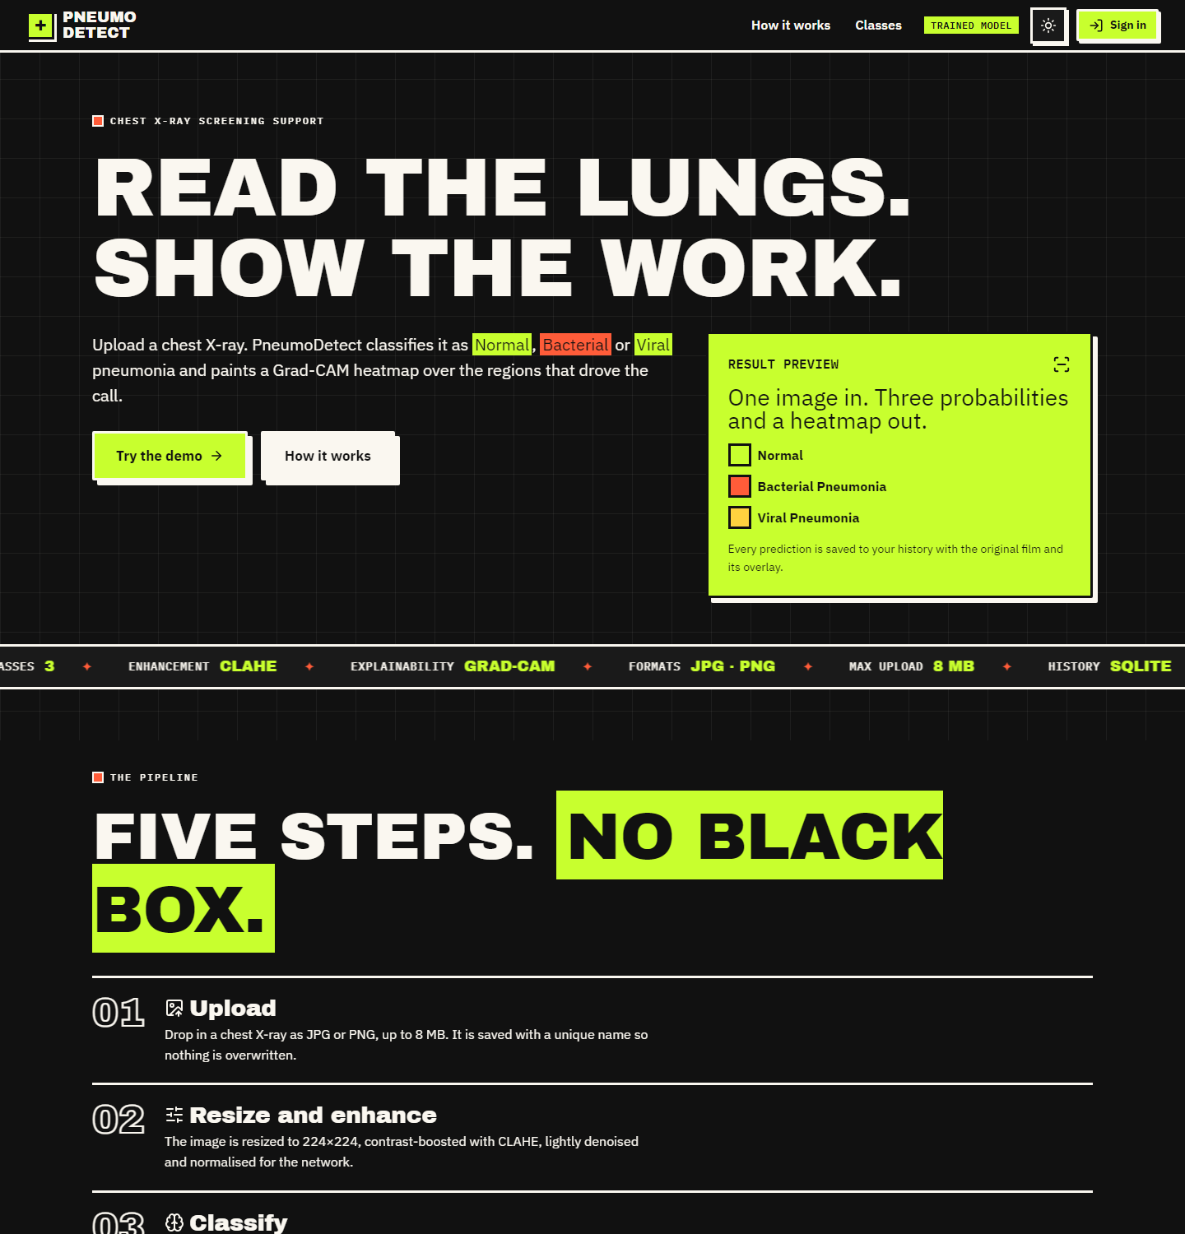
Figure 31: Landing page, dark theme
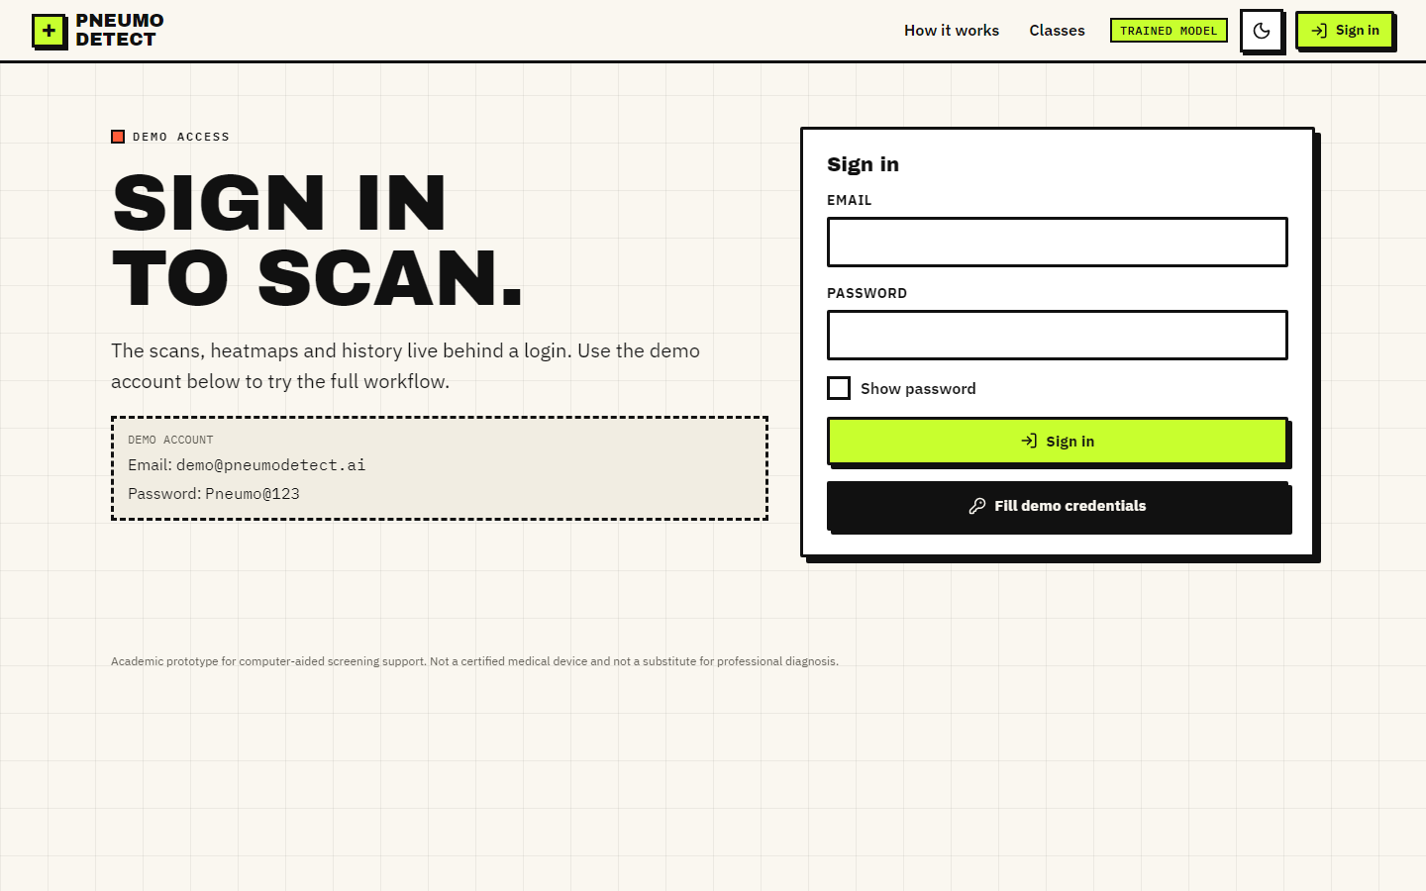
Figure 32: Sign-in screen with the demo credentials box
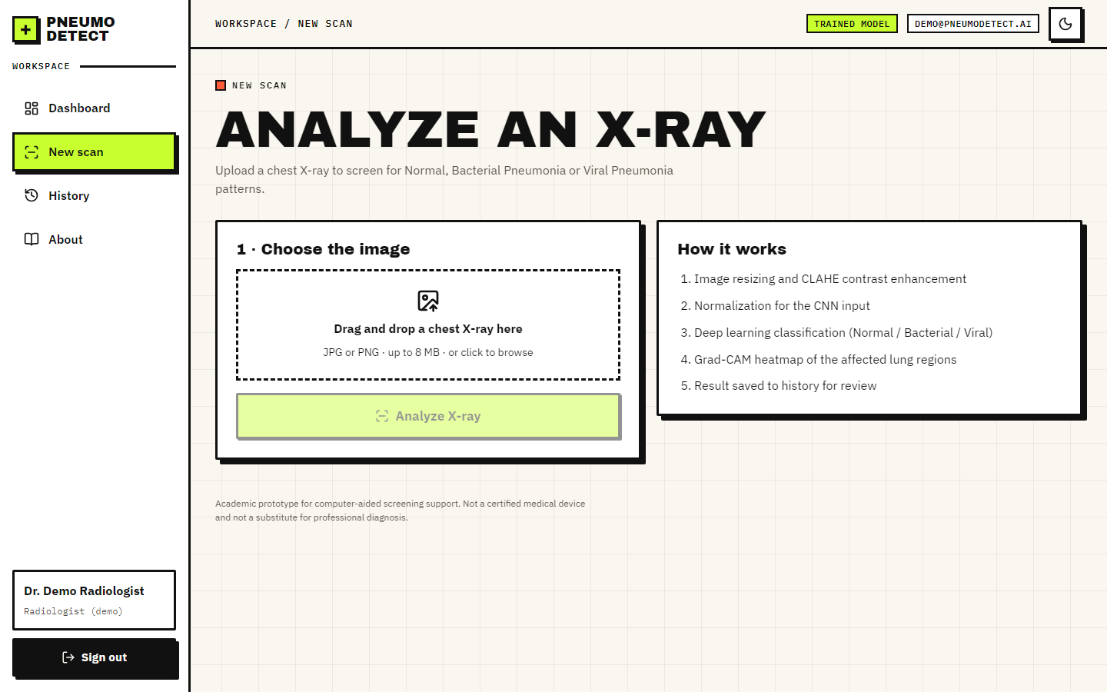
Figure 33: Detect screen before a file is chosen
Figure 34: Detect screen with a preview and the analyse button
Figure 35: Result screen, blended heat-map view
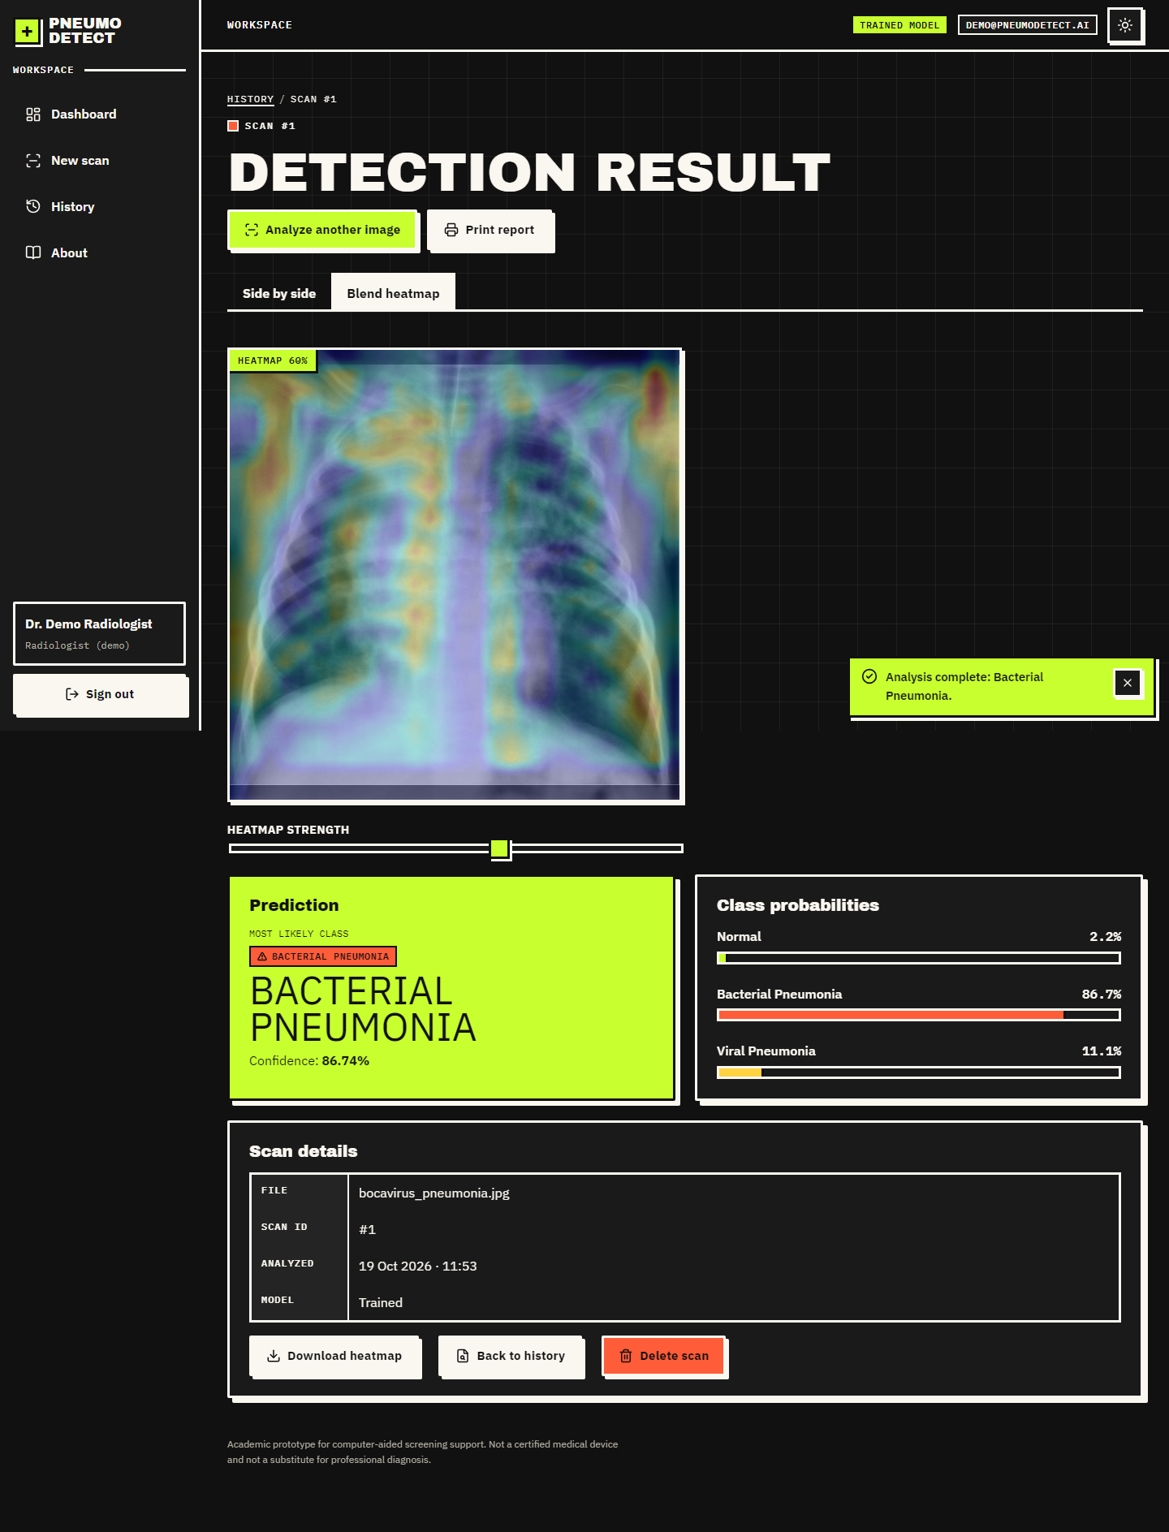
Figure 36: Result screen, dark theme
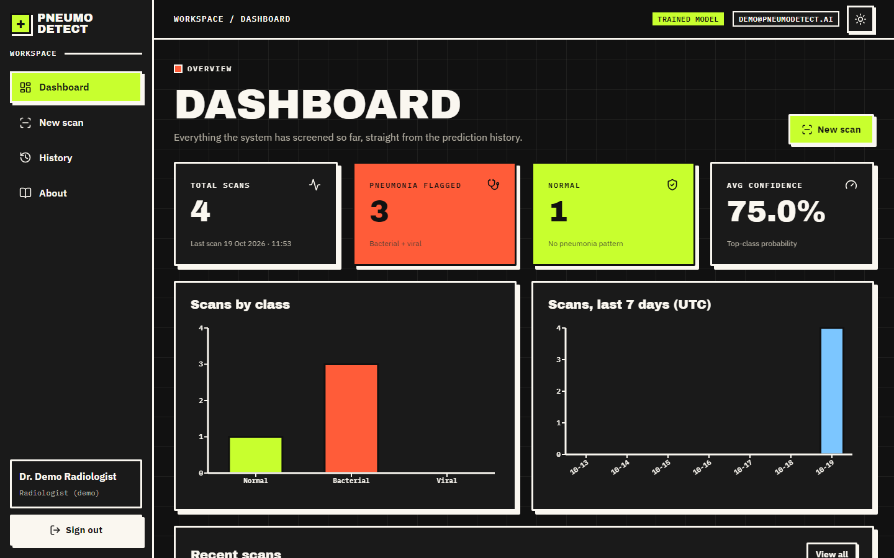
Figure 37: Dashboard, dark theme
Figure 38: About screen
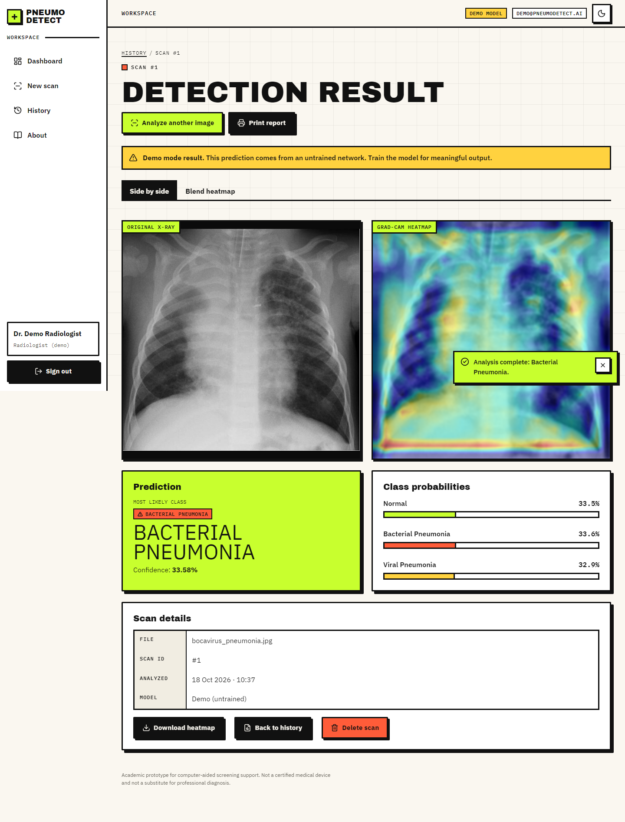
Figure 39: Result screen in Demo Mode (untrained network, before the model was trained): the amber banner and the near-equal probabilities are the warning that the output is meaningless
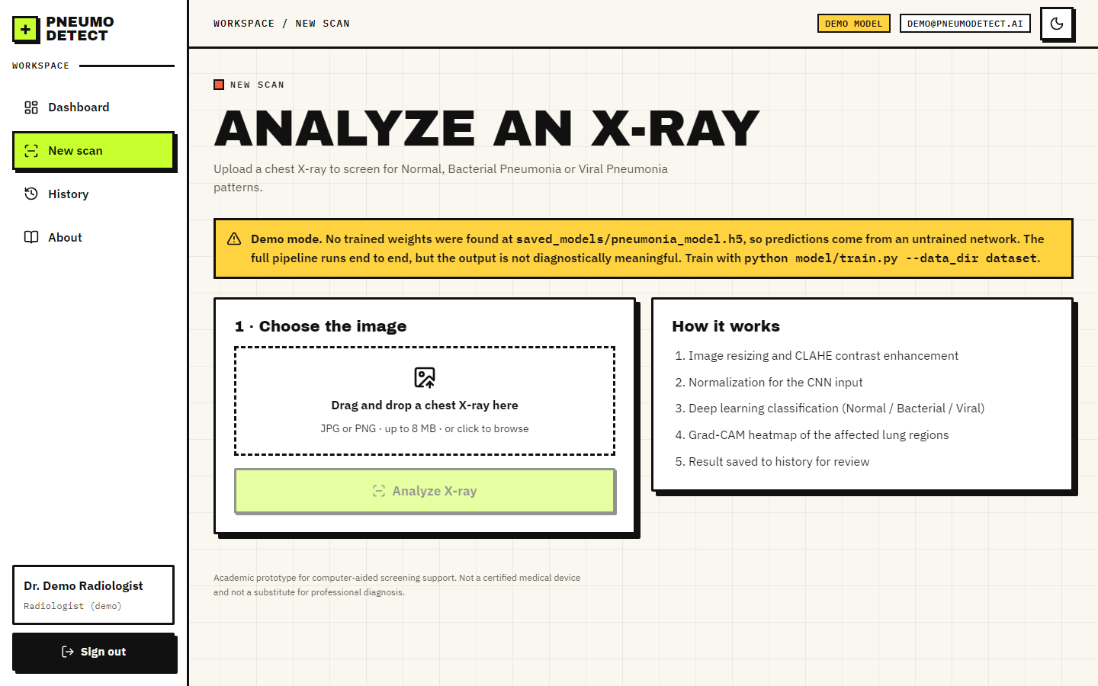
Figure 40: Detect screen in Demo Mode

